Service Bulletin - Integrated Encoder
Change log:

[2023:10]
PRODUCT INVOLVED: GD, GDI and NL120Q/X series.
STARTING FROM S/N: DA00014400
ACTION: Encoder SIN/COS Electronics changed.New signal conditioning, filtering and digital calibration.
- Protection against wrong voltage application, voltage invertion and output protections.
- Better signal quality, Offset cancellation and Peak to Peak variation reduction
- Digital Filtering
WARNING:
1) New phase angle must be calculated from the servo drive !
2) Possible deviation of the tuning parameters on the servo drive
3) Possible needs to retuning the offset and gain if a calibration on the servo drive is present.

IMPROVEMENTS:

PREVIOUS ENCODER VERSION:
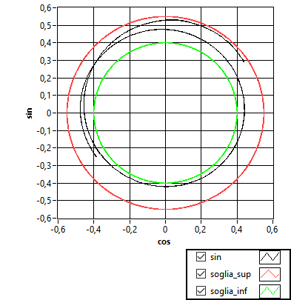 | 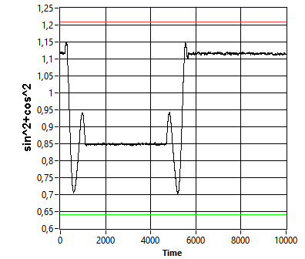

NEW ENCODER VERSION:
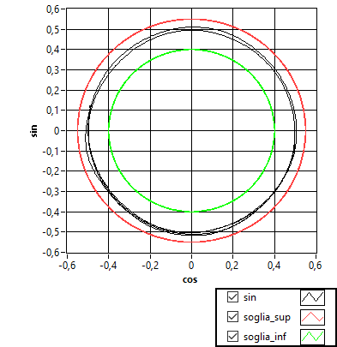 | 

