Dimensional details

DA20262702 - RM075P-3615-260 (260mm of stroke)
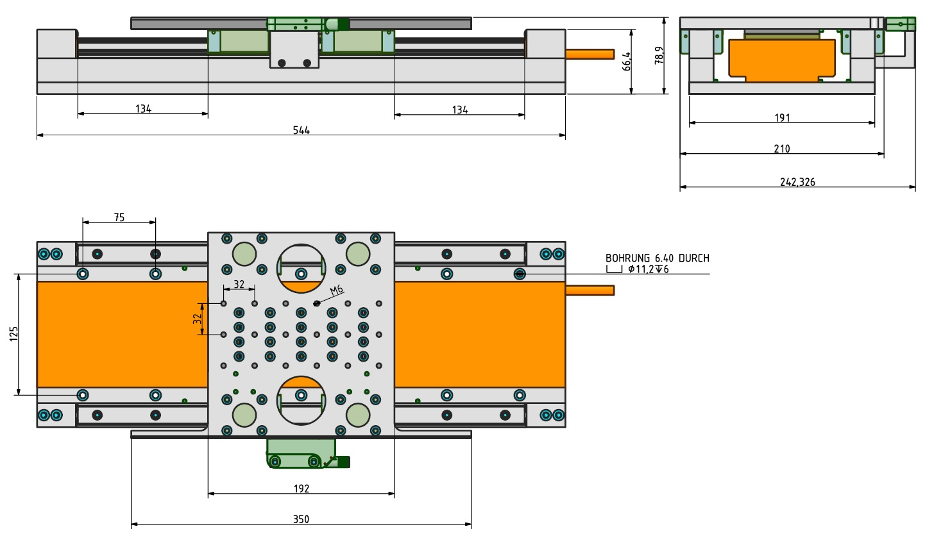rm075p-3615-210.jpg

DA20260303 - RM075P-2415-120 (120mm of stroke)
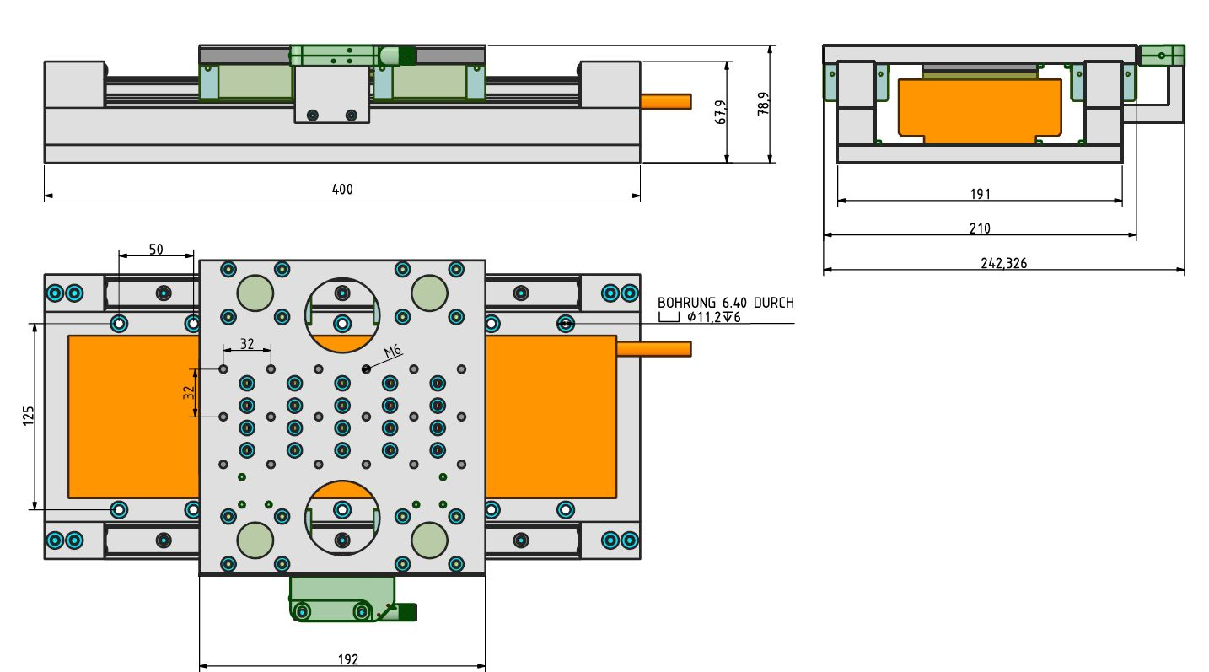rm075p-2415-120.jpg

