Carriage Mounting / Dismounting procedure
In order to replace the linear guiding blocks or a damaged magnets, please proceed as following:

Step 1 - Remove the standard M5 linear guiding blocks screws from the carriages
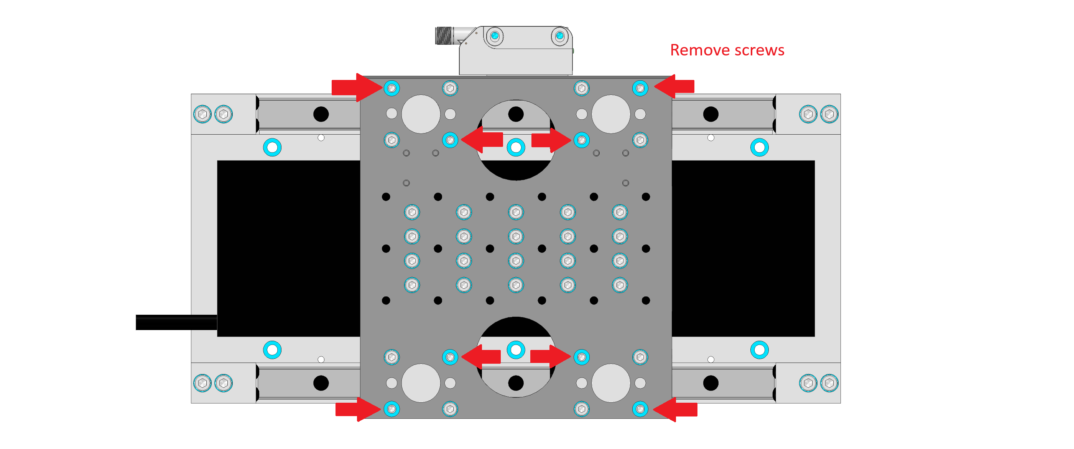

Step 2 - Mounting M5x50 screws instead of the M5 standard screws
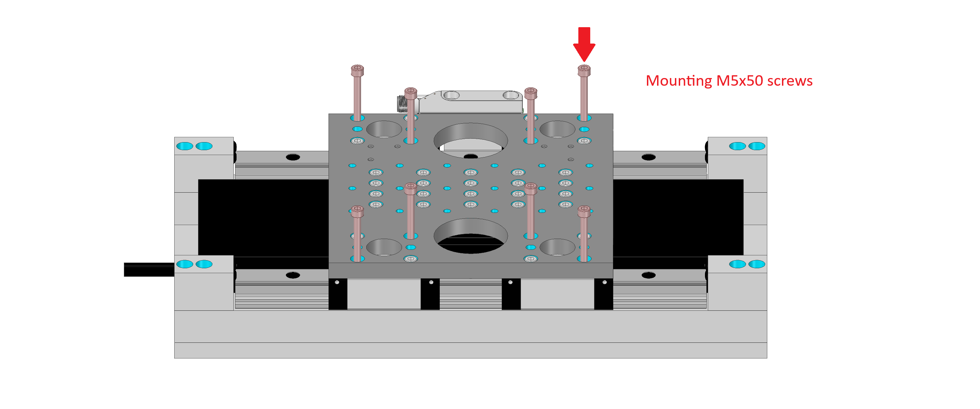

Step 3 - Remove the linear guiding blocks screws
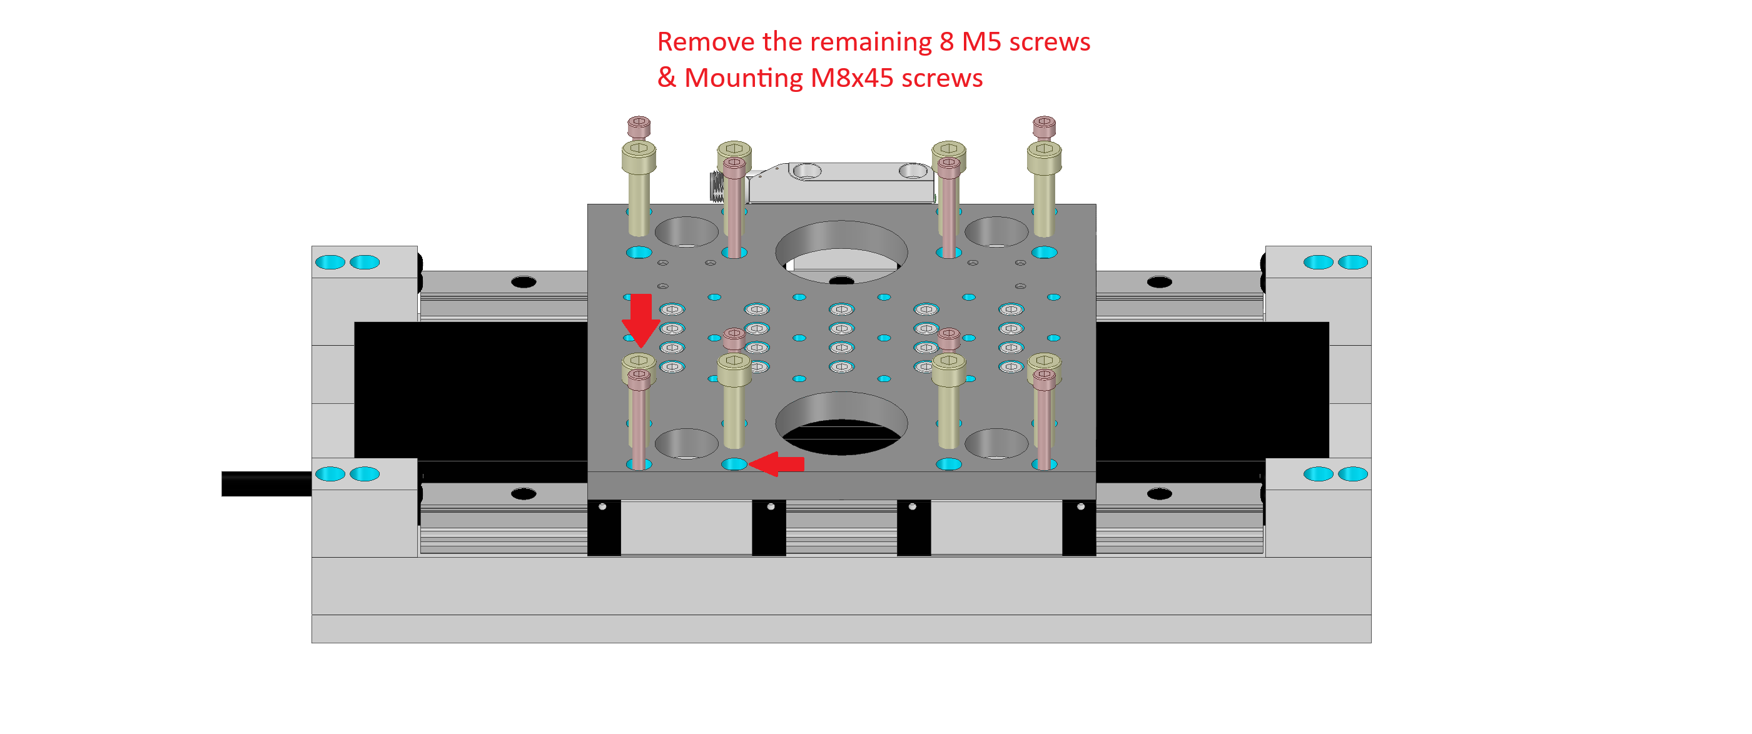

Step 4 - Screw the M8 screws to lift the carriage
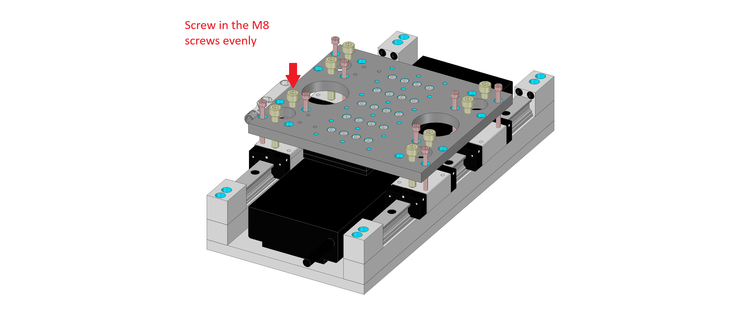

Step 5 - Insert a wood block between the primary part and the magnet and remove the M5


