NL7 Servo Drive
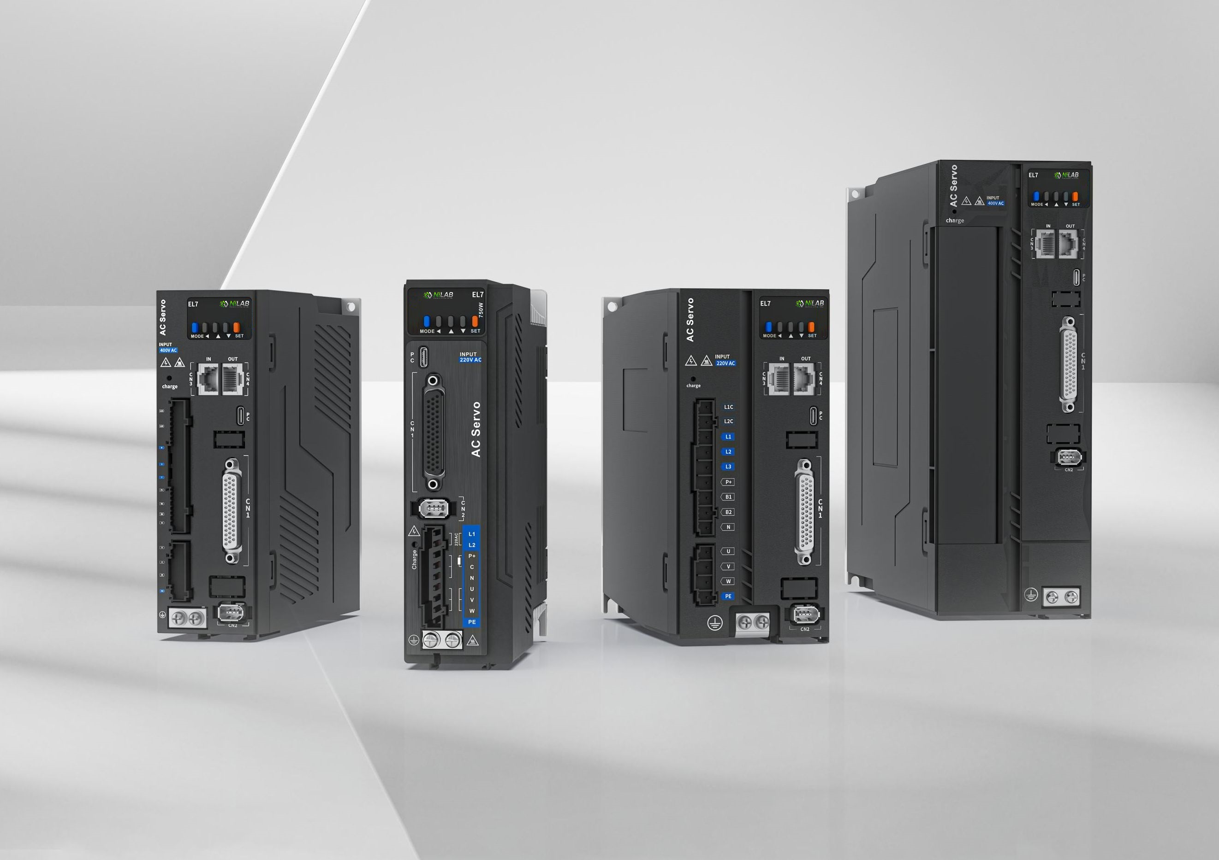nl7_servo_nilab_2024.jpg
NL7-EC Series AC servo products are high performance AC digital servo which is designed for position/velocity/torque high accurate control with power rating ranging up to 7.5kW which provides a perfect solution for different applications with easy tuning process. Based on the ETG COE + EtherCAT DSP402 protocol, it can be seamlessly connected to controllers/drives that support this standard protocol. EL7-EC series AC servo drives are using the latest Digital Signal Processing (DSP) chip and Intelligent Power Module (IPM) with compact components integration and great reliability. Using the best PID calculation for Pulse Width Modulation (PWM) control, our EL7-EC series products are the one to beat in this product category.
In comparison to conventional pulse controlled servo drives, our EL7-EC provides advantages as listed below.
- Lengthen communication range and lower electromagnetic interference
Due to the reliance of pulse command, pulse controlled servo drives could be easily disrupted by electromagnetic interferences. EtherCAT communication protocol provides fault detections limitations and error handling that makes communication more reliable over long distances.
- Greater motion control
Trajectory generation can be done within the driver under non-cyclic synchronous mode. Controller only needs to deliver target position, velocity and acceleration commands to the driver. Drivers can then achieve greater control by applying feedforward to the commands.
- Simplify complex wiring work
Using EtherCAT communication protocols, the connections between master device and slave stations can be realized using only LAN cables.
- Reduce cost by lowering the requirement for more ports
Multiple axes control can be realized without requirement for more ports or pulse module on the master device/controller. Only a network port is needed to chain the axis controller (drivers) together in series.

