Encoder cables

Motor frame size 80 mm or below

AMP connector - CABLE-7BM*-Z(V3.0)
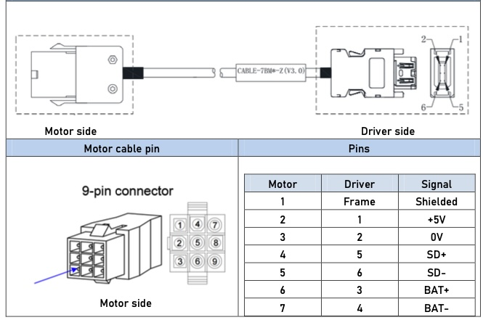enc_cable_1.jpg

Aviation connector - CABLE-7BM*-HH2
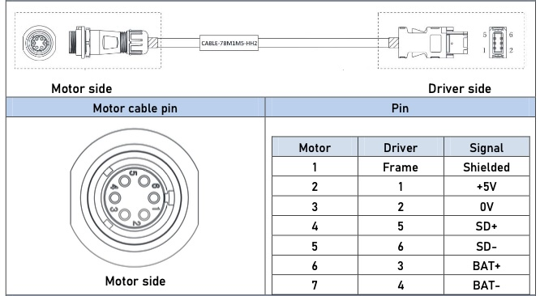enc_cable_2.jpg

Direct connector - CABLE-BMAH*M*-124-TS - Absolute encoder
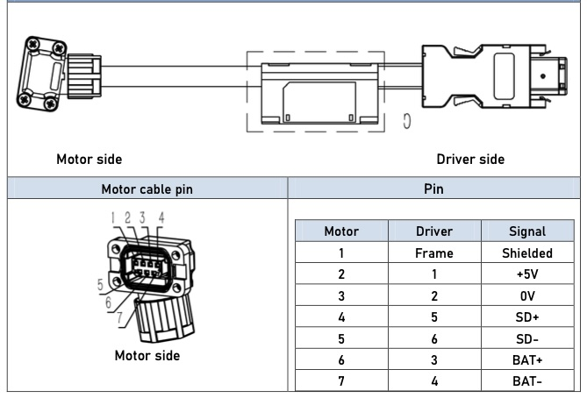enc_cable_3.jpg

Motor frame size 130 mm

Aviation connector - CABLE-/BM*HZ(V3.0)


