Alarm Codes

Alarm clearing
Method 1：
By setting bit 7 of 6040h to 1, switches state machine from fault to initialization completion , No fault(Switch on disabled).
Method 2：
Use auxiliary function “AF_ACL”
Press M to select auxiliary function , Press SET to enter into “AF_ACL” , Press and hold to clear the alarm
Method 3：
Set IO input function as Alarm clear input “ (A-CLR)”，refer to switch input interface connection to clear the alarm.

Alarm List
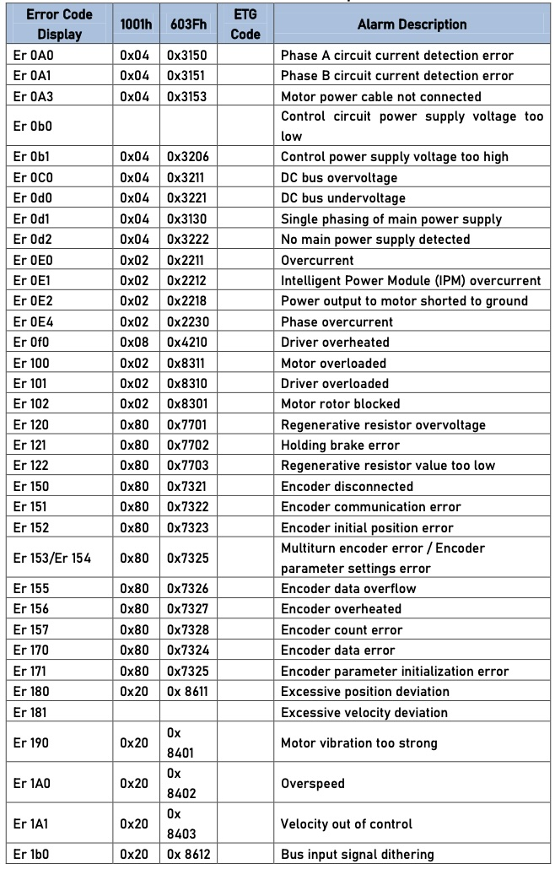alarm_1.jpg
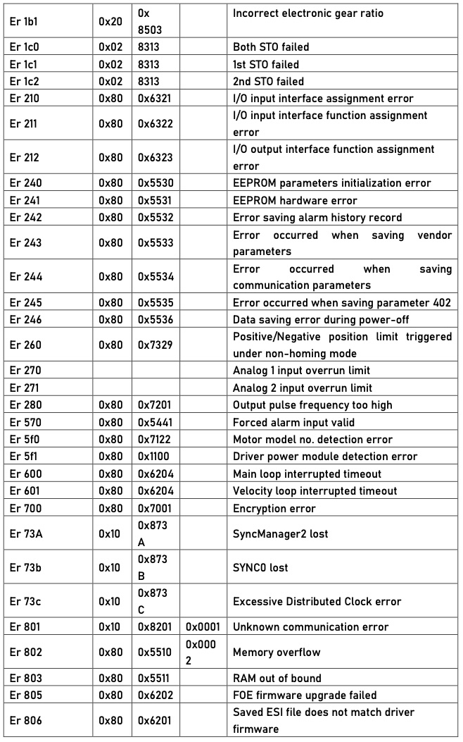alarm_2.jpg
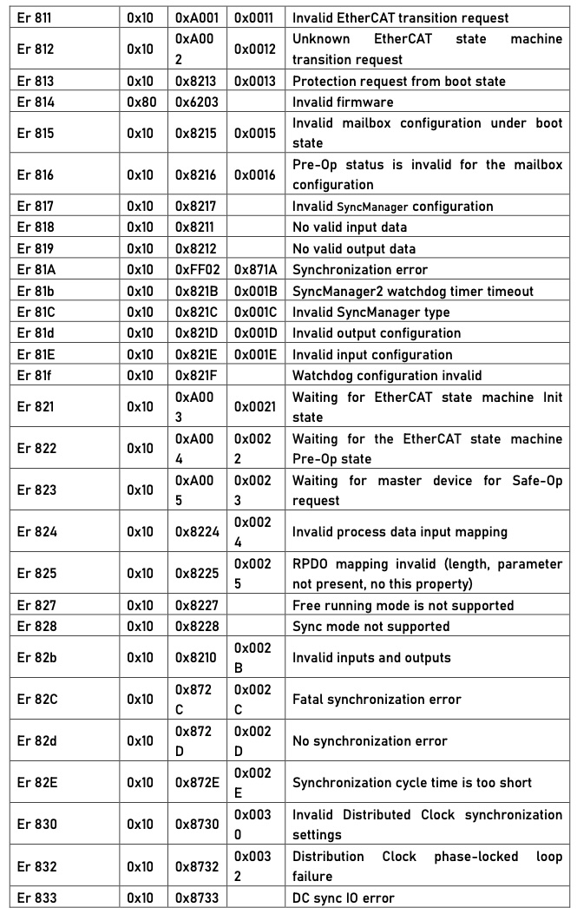alarm_3.jpg
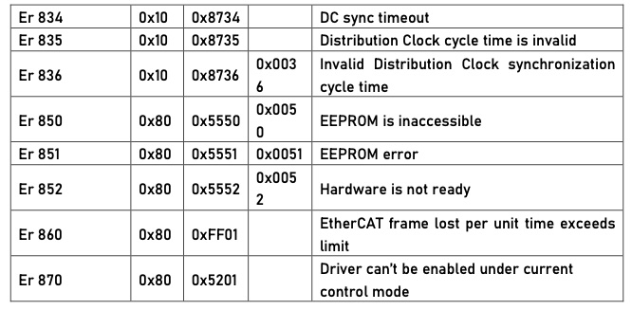alarm_4.jpg

