Connector pinout
The motors are equipped with 5 meters cable with D-SUB 9 female connector.
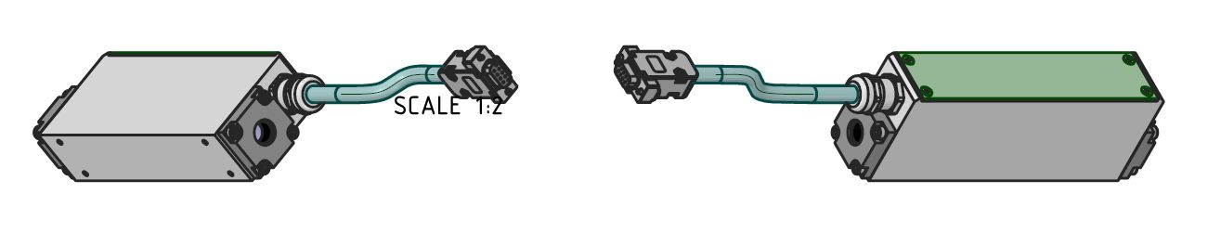
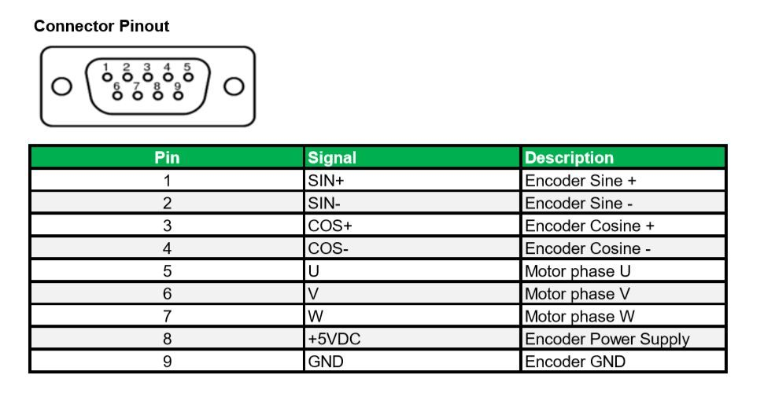pinout_miniature.jpg

