Motor feedback

Rotary motor feedback
The standard feedback device used is an incremental encoder with Hall.
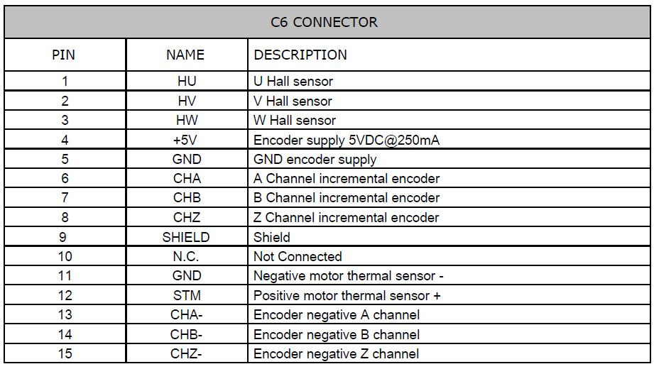

Linear motor feedback - SIN/COS 1Vpp


