Integrated Encoder

Standar option: Absolute magnetic TTK50 Sick
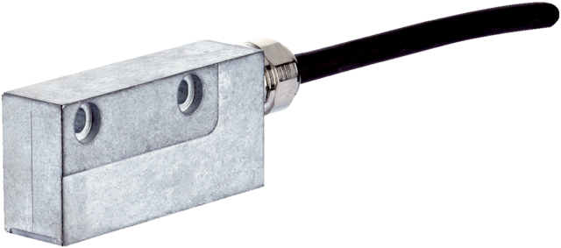
Precision, speed, dynamics, stiffness and high control accuracy - it is exactly these properties which play an important role in high-end applications in drive technology. The TTK50 linear measurement system has all these properties and is a very compact motor feedback system with HIPERFACE® interface. The magnetic principle of operation, the long measuring length, and the extremely high resolution open up all kinds of application possibilities for absolute position detection with linear motors. The TTK50 contains the newest sensor and evaluation technology. The sensor board aligned to the measuring plane is equipped with Hall sensors in two parallel tracks. Their arrangement corresponds with the division of the magnetic tape into an incremental and an absolute component. To calculate the absolute position values during operation, the read head initially detects the absolute starting position when the linear motor starts. All other actual positions of the drive are then determined via the incremental position on the magnetic track or the sine/cosine signals.

Characteristics
Parameter | Value
Resolution | 1 microns
Magnetic pitch | 1 mm
Repeatability | < 5 microns
Accuracy | +/- 10 microns
Interface | SIN/COS + Hiperface RS485

Pinout
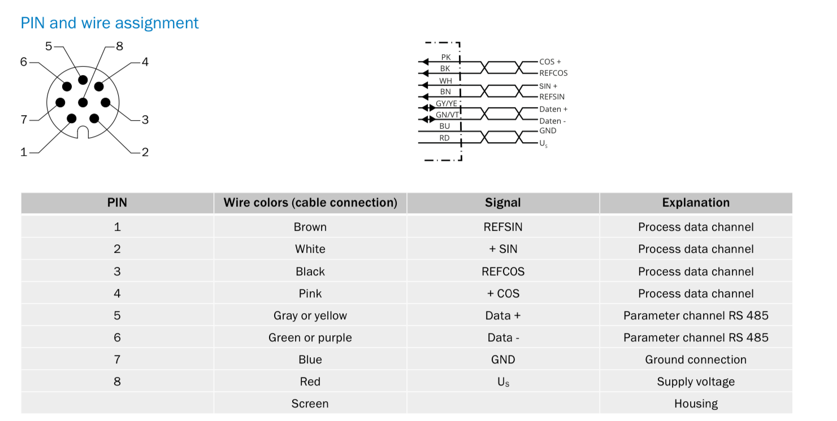

Second option: Absolute optical encoder LIC411 Heidenhain
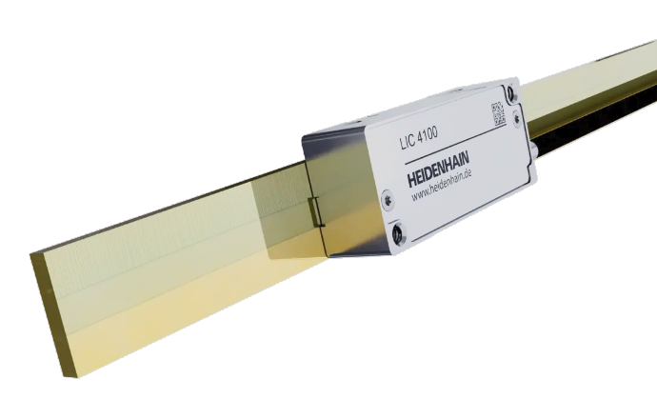

Characteristics
Parameter | Value
Resolution | 0.01 microns
Grading scale pitch | 1 mm
Repeatability | < 0.1 microns
Accuracy | +/- 3 or +/- 5 microns
Interface | Endat 2.2

Pinout
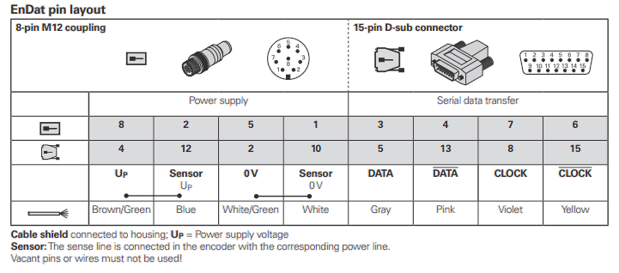

Secondary encoder Temposonic (Optional)
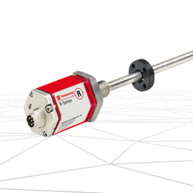temposonic.jpg

Pinout


