Electrical Connections

Connection between the two motors
The pick and place robot works with 2 external signal provided by the PLC or sensor. Trigger signal is the start signal for the pick and place sequence stored inside the two motors using NiLAB Starter Software. Enable signal is to switch on for the two motors provided by the PLC. Normally, when the motors are configured as pick and place every Disable the two motors performed homing procedure (Soft landing) to ensure a parking position for the robotic hands.
In position outoput signal is the signal generated by the slave motor at every positioning task. For example if the pick and place is programmed with 4 motion tasks this signal change for 4 times. Master sync is the signal generated by the master motor to synchronize the motion of the second motor slave.
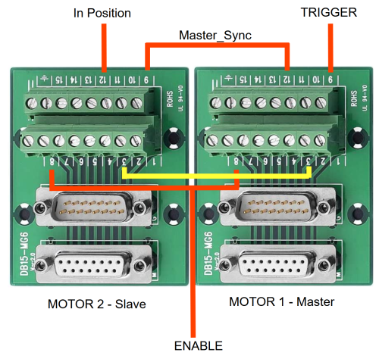
The signal must be connected together as in the table below (with reference to the photo above)
SIGNAL | MOTOR 1 | MOTOR 2 | DESCRIPTION
ENABLE | Pin 8 | Pin 8 | Switch-on the motors
TRIGGER | Pin 9 | - | Motion trigger from PLC
Master_sync | Pin 12 | Pin 9 | Master signal for synchronization
In Position | - | Pin 12 | In position signal from Slave
GND | Pin 3 | Pin 3 | Ground signal

How to identify the motor
The master motor (motor 1) is the upper motor in the pick and place assembly, as reported in the drawing below:


