MODBUS RTU debug mode
in order to test without PLC and NiLAB Starter software the correct connection of the MODBUS RTU fielbus lines. The motor is able to send automatically a string after motor controller boot.
In order to enable this function, the parameter 4097 must be set to zero corresponds to no I/O control (this is the default value when the motor is shipped from the production) and the two digital inputs must be connected to 24VDC before powered the motor. The Firmware version must be >= 5E39.
The motor will be send the following information, corresponding to 4 bytes and the state of the motor will be set to SAFE STOP.
1. Slave ID (1 byte)
2: Firmware version (2 bytes)
3. Motor type (1 byte)

Example using Realterm
Realterm is opensource sofwtare and can be downloaded here: RealTerm: Serial/TCP Terminal download | SourceForge.net
Please select in display ⇒ Hex(Space) as Display time, in Port select the right COM (in this example COM2) with 38400 baud, Parity Even, Databits 8, Stop bits = 1.
After the switch on of the power supply of the motor and the blinking of the two leds (blinking means booting in progress), the motor will send the string like this:

Correct reply of the motor when the MODBUS RTU fieldbus is connected in a right way.
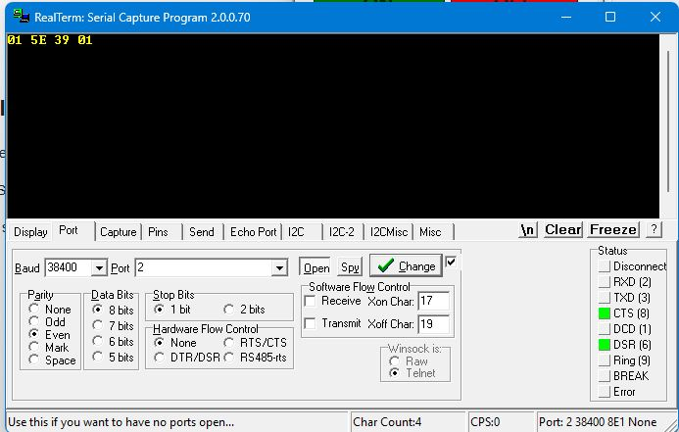term.jpg
0x01 ⇒ Node id of the motor, 0x5E 0x39 ⇒ Firmware version, 0x01 ⇒ NL080Q motor type.

Incorrect reply of the motor when the MODBUS RTU fieldbus lines are swapped.
the first and the last byte are 0x00 and the 4 bytes between are wrong.
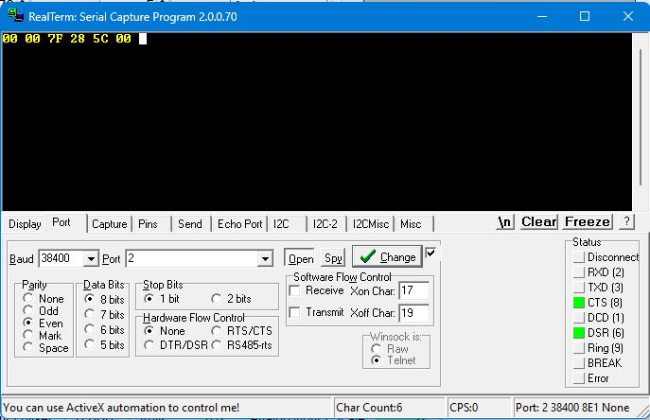term_1.jpg

