How to use connectors

How to use speedtec connector
The standard connection system based on speedtec connector on the cable must be used with the right aligment before push inside the connector on the motor side. Please use the marker on the two connectors to avoid permanent damaged to inside parts of the connector on the motor side. (see photo below)

Power Side
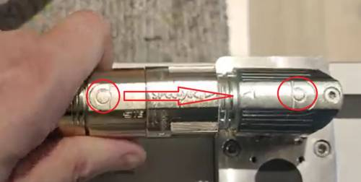speedtec_connector.jpg

Signal Side
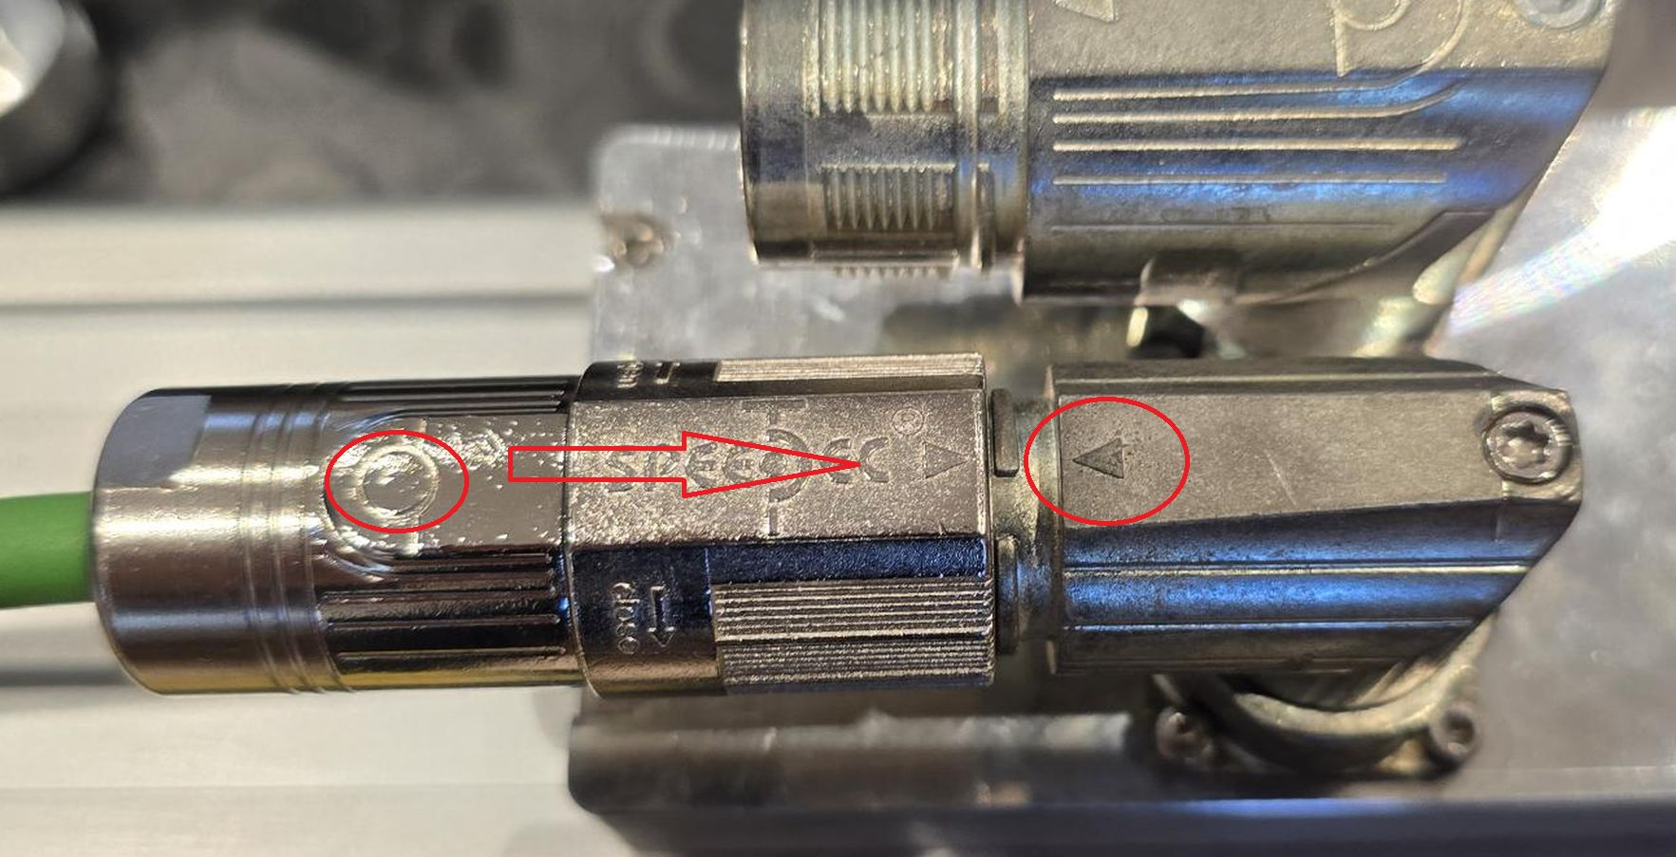
IF THE ALIGMENT IS WRONG AND IF YOU FORCE THE CONNECTOR TO ENTER YOU DAMAGED
THE INTERNAL PIN HOLDER AND THE ENCODER FEEDBACK WILL STOP TO HAVE A CONNECTION TO THE DRIVE !!!!
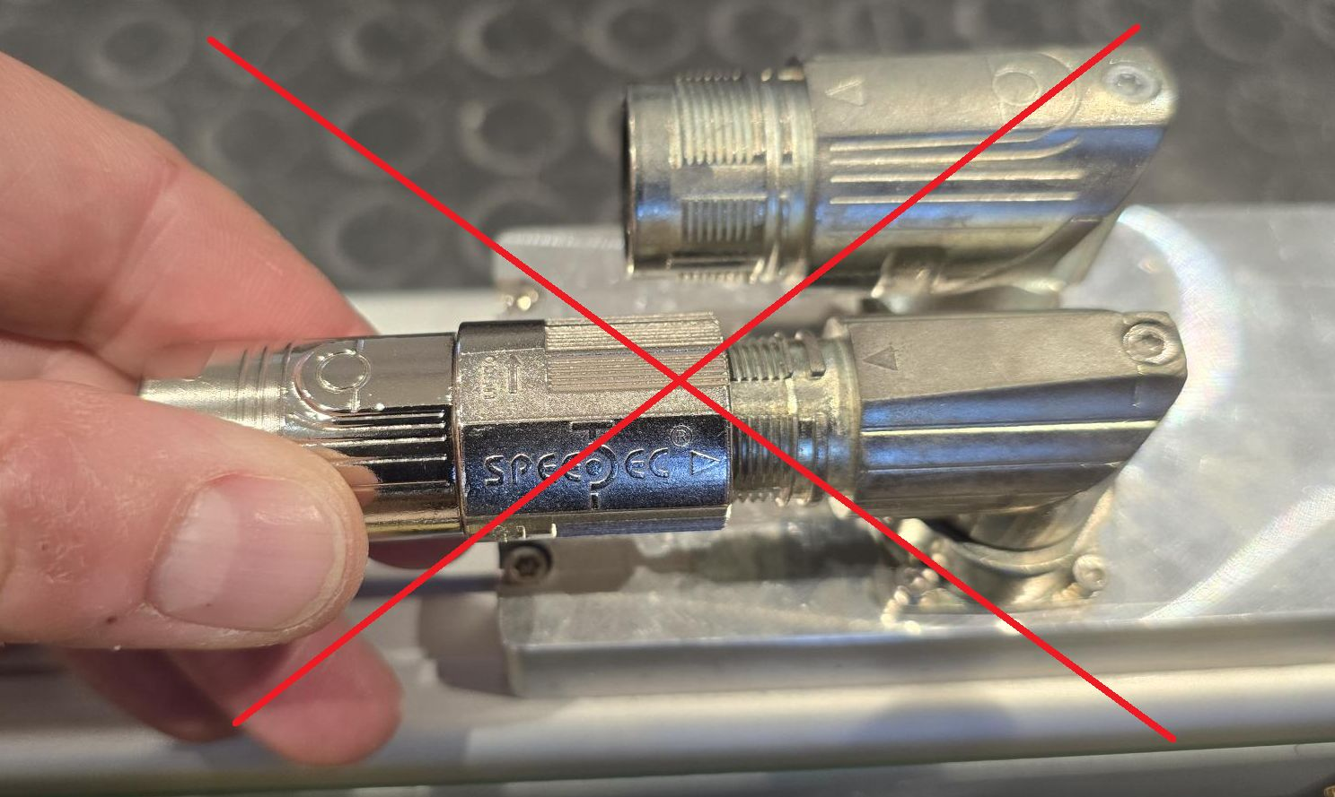signal_steck_not_ok.jpg

How to see if the insert is damaged or not
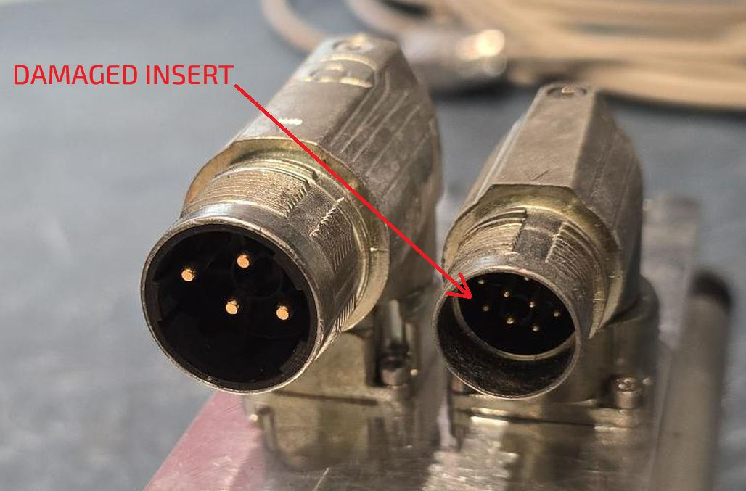 | 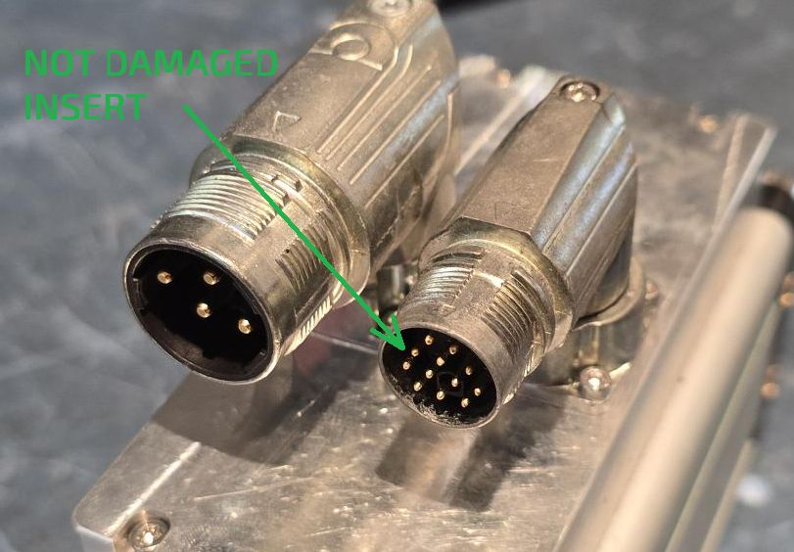
DAMAGED INSERT IS NOT ALIGNED WITH THE CONNECTOR FRONT SIDE | NOT DAMAGED INSERT IS ALIGNED: ALL THE PINS ARE ALIGNED WITH THE FRONT SIDE

How to use standard connector

How to rotate the connector

