Input / Output Signals
PLEASE PAY ATTENTION ABOUT THE CONNECTIONS BETWEEN OUTPUT SIGNAL OF THE MOTOR AND THE PLC !
OUTPUTS ARE NOT PROTECTED AGAINST EXCESSIVE CURRENT REQUEST (MAX 100mA).
IF THE OUTPUTS WILL BE CONNECTED TO GROUND OR LOW RESISTANCE LOAD WHEN THE MOTOR IS ENABLED THE OUTPUT PNP TRANSISTOR WILL BE DAMAGED PERMANENTLY.

Input signals
the inputs are protected from inversion and overvoltage. The logic level is 24VDC.
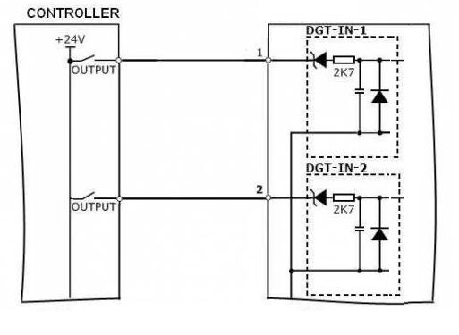io_sig.jpg

Output Signals

PNP - Default type (Default type - With 24VDC drive)
The digital output signals are by default PNP type (without internal pull-down).
The absolute current capability is 100mA per output lines.
FOR CORRECT OPERATION TO AVOID DAMAGED USE TYPE 2, EN 61131-2 Input characteristic curve on PLC Input.
IN THIS CASE THE CURRENT DRAW FROM THE PLC INPUTS IS TYPICALLY < 10mA
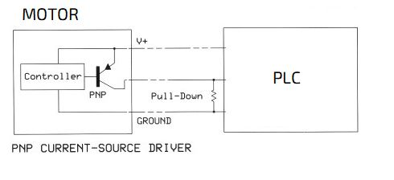io_sig_2.jpg

NPN Type - 48VDC compatible drive
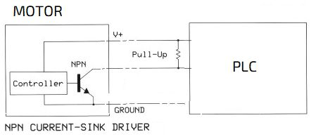io_sig_1.jpg

