Register mapping
The Epulse50 registers are divided in Input Variables, Output Variables, Drive Parameters and Motion parameters.
The registers can be accessed using MODBUS RTU via serial connection or CANopen fieldbus.
Between the MODBUS address and CANopen address there is a displacement of 0x2000.
Parameter type | MODBUS address | CANopen address
Servo parameter | 0x00 to 0x3FF | 0x2000 to 0x23FF
Input variables | 0x1000 to 0x103F | 0x3000 to 0x303F
Output variables | 0x1200 to 0x123F | 0x3200 to 0x323F
You can use the TKSED Software to see the corresponding parameter description.

Input Variable table
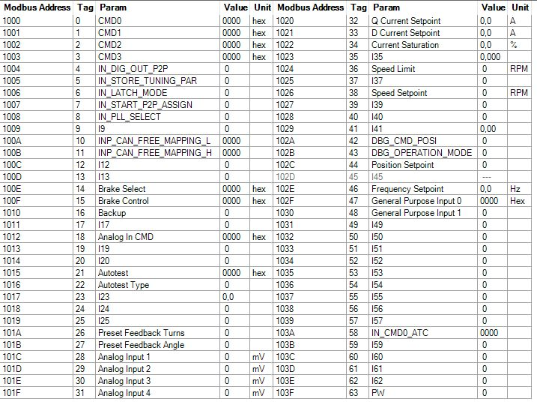input_param.jpg

Output Variable Table
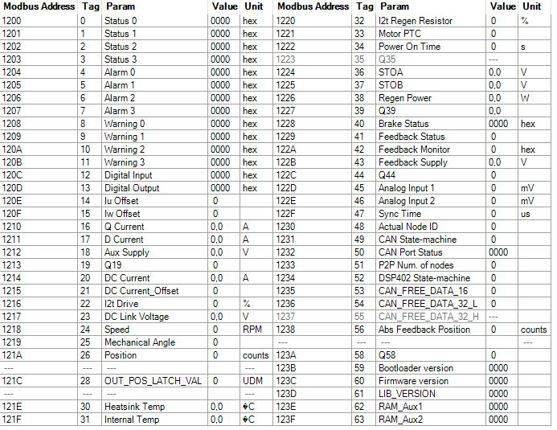var_out.jpg

EDS (CANopen) file
EDS File: https://www.nilab.at/download/mbd-tbs1-eds-file/?wpdmdl=2134&refresh=637351b05ed9d1668501936

