ULCO 132
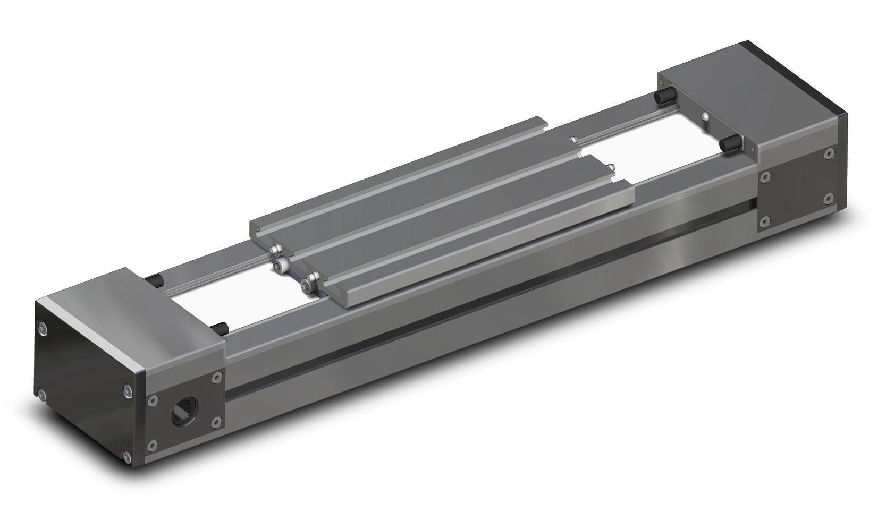

Mechanical Drawing
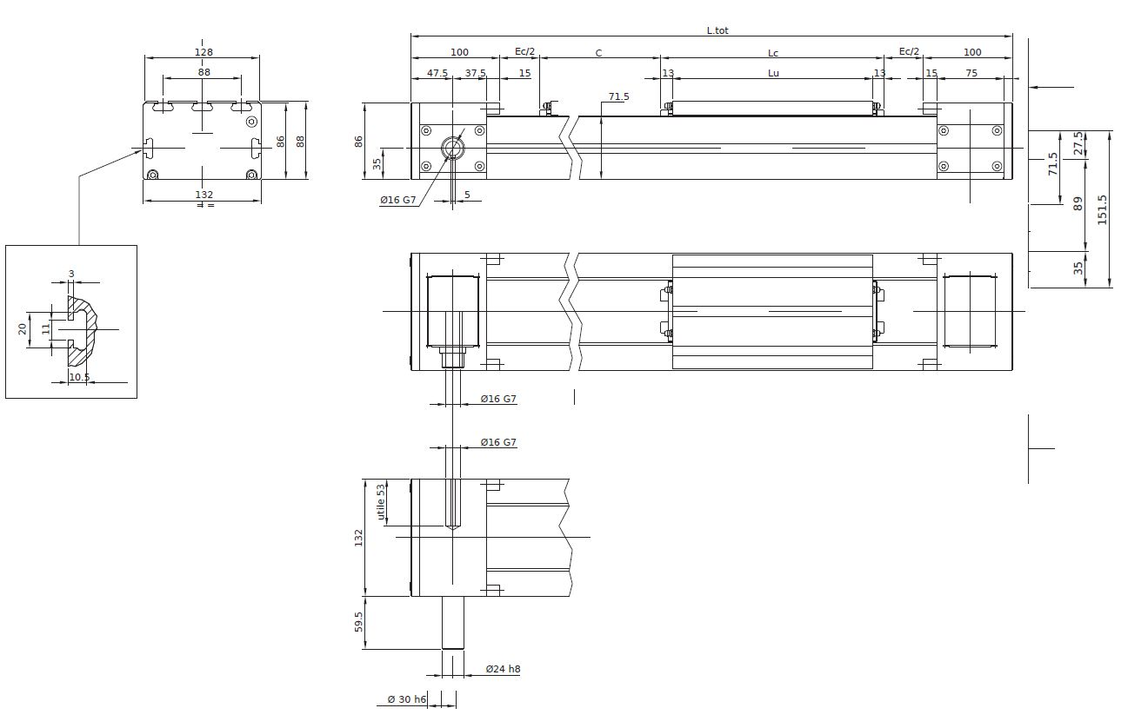

Load rating
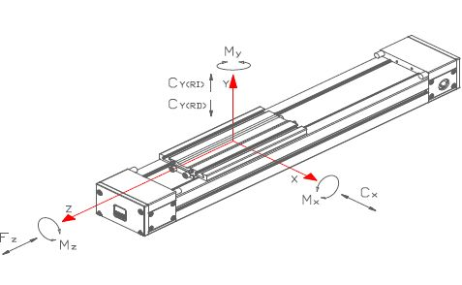

Technical data
Parameter | Symbol | Value | Unit
Max usable stroke |  | 6500 | mm
Total lenght | Ltot | C+Lc+260 | mm
Carriage length | Lc | 290 | mm
Carriage usable length | Lu | 270 | mm
Extra-stroke (safety) | Ec | 60 | mm
Max speed |  | 180 | m/min
Max acceleration |  | 100 | m/sec2
Position repeatability |  | < 0.05 | mm
Aluminium profile section |  | 132 x 71 x 5 | mm
Inertia momentum of aluminium profile | Ix | 1413267 | mm4
Inertia momentum of aluminium profile | Iy | 2429437 | mm4
Type of mechanic |  | linear guide with compact block
Belt type |  | Poliuretan HTD-5M-75
Pulley teeth number |  | 36
Diameter |  | 57,3 | mm
Linear movement per rotation |  | 180 | mm
Operating temperature |  | -20 / +60 | degrees

