Accessories

Sensor switch
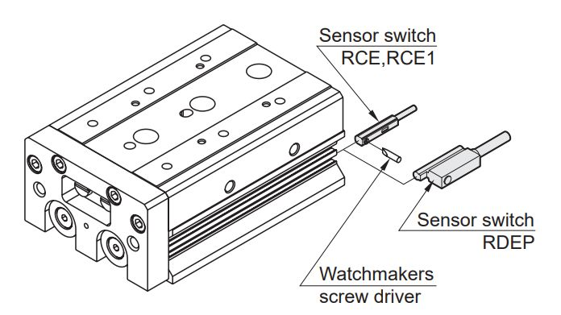sensor_switch.jpg

Maglift - Magnetic spring for vertical counterbalance

