RM Linear Stage
This series is design for high speed, high acceleration application. The linear stage includes high performance linear guide and absolute encoder.
Different strokes are available.
Target application are Diaper production, Wrapping machines, Packaging machines, Food and Beverage production
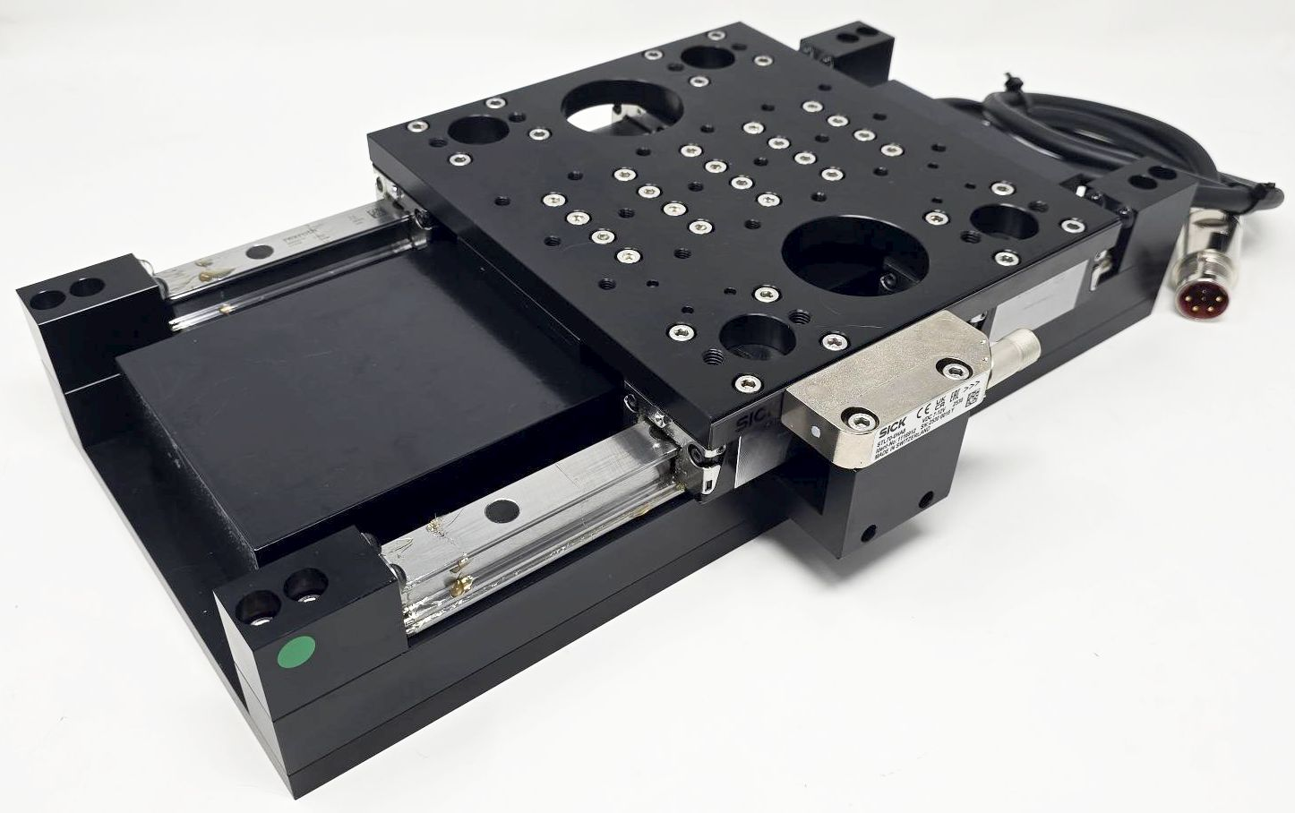rm_photo_1.jpg | 

