Linear guide
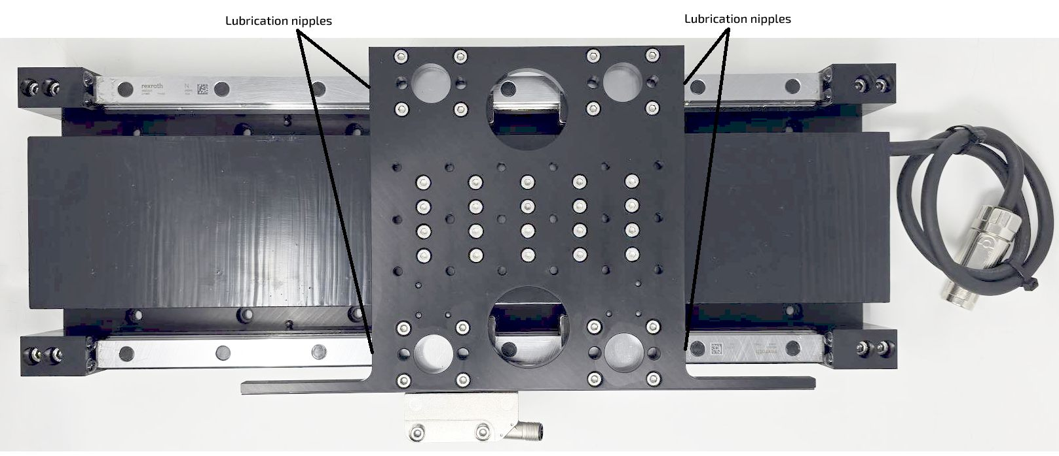lubrication_points.jpg
The linear guiding system is based on high performance Bosch Linear guides designed for high acceleration and high speed movements.
The system is composed by 4 linear guide blocks size 20 carbon steel (medium preload) with 4 independent lubrication nipples.
Lubrication use is Roller bearing grease Dynalub 510.

Linear guide performance
Parameter | Value | Unit
Maximum acceleration | 500 | m/sec
Maximum speed | 5 | m/sec
Dynamic load capacity per block C50 | 29.5 | kN
Static load capacity per block C0 | 29.8 | kN
Accuracy class | H
Preload class | C2
Permissible ambient temperature | -10 / +80 | degrees
Typical lubrication frequency at high speed / high acceleration | 1000 | km

