Installation picture
Picture | Bracket name | Accessories
 | End cap with hole for mounting | M4 x 20 screws (4 pieces)
 | Metal end cap flange | M3 x 6 screws (8 pieces)

Application photo
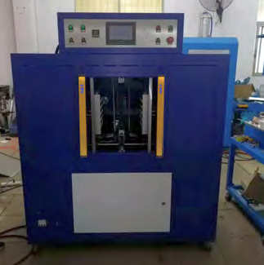 | 

