Wiring Diagram

How to fix wire cables into connector
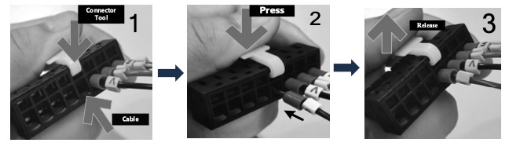how_to_fix.jpg

230VAC Version
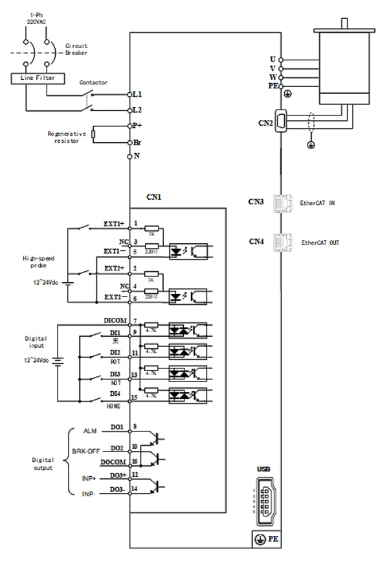
NL7-RS series servo drive supports single phase and three phase 220VAC. Only driver with power rating above 1500W supports three phase 220VAC.
- Please use a circuit breaker for the main power supply to prevent damage to the product or machine.
- Please do not use a contactor in connection to servo motor as it may not withstand a sudden surge of operating voltage.
- Please take note of the capacity when connect to a 24VDC switching power supply, especially if power supply is shared between multiple components. Insufficient supply current will cause failure in holding brake functions.

380VAC Version
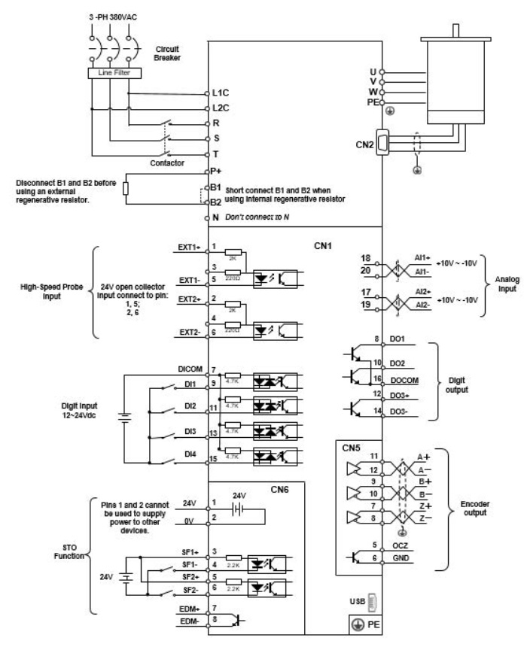
- Please use a circuit breaker for the main power supply to prevent damage to the product or machine.
- Please do not use a contactor in connection to servo motor as it may not withstand a sudden surge of operating voltage.
- Please take note of the capacity when connect to a 24VDC switching power supply, especially if power supply is shared between multiple components. Insufficient supply current will cause failure in holding brake functions.

