Power Port Pinouts

Overview
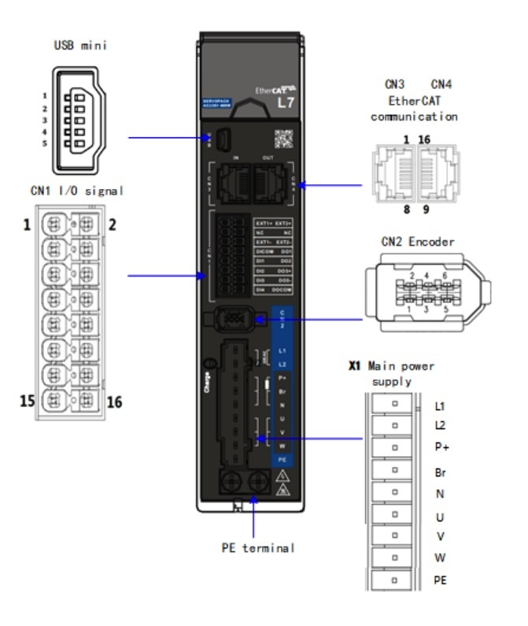port_3r.jpg
Port | Function
CN1 | I/O Signal Port
CN2 | Encoder Port
USB | USB Mini port
CN3 | EtherCAT In Communication port
CN4 | EtherCAT Out Communication port
CN6 | STO Safe Torque Off port
X1 | Main Power Supply

X1 Port main power supply (230 VAC models)
Pin | Functions | Remarls
L1  L2 | Single phase 220 VAC | 1) Optional isolation transformer  2) Do not connect to 380 VAC directly to prevent damage to drive  3) In case of serious interference, it is recommended to connect a line filter to main power supply;  It is recommended to install a fuseless circuit breaker to cut off power supply in time when the driver fails.
P+ | 1) Internal DC bus positive terminal  2) External regenerative resistor P terminal | Please refer to Regenerative resistor selection and connections
Br | External regenerative resistor terminal | Please refer to Regenerative resistor selection and connections
N |  | Please do not connect
U | Motor U phase terminal | Please ensure proper wire connection on motor.
V | Motor V phase terminal | Please ensure proper wire connection on motor.
W | Motor W phase terminal | Please ensure proper wire connection on motor.
PE | Motor potective Earth | Please ground PE of driver and motor together

X1 Port main power supply (380 VAC models)
Pin | Functions | Remarls
L1C  L2C | Control circuit: Single phase 380VAC | 1) Optional isolation transformer  2) In case of serious interference, it is recommended to connect a line filter to main power supply;  It is recommended to install a fuseless circuit breaker to cut off power supply in time when the driver fails.
R  S  T | Main Power Supply: Three phase 380VAC，  +10～-15%，50/60Hz | 1) Optional isolation transformer  2) In case of serious interference, it is recommended to connect a line filter to main power supply;  It is recommended to install a fuseless circuit breaker to cut off power supply in time when the driver fails
P+ | 3) Internal DC bus positive terminal  4) External regenerative resistor P terminal | If an external regenerative resistor is required, please disconnect B1 and B2. Connect the external regenerative resistor to terminal P+ and B2.
B1/B2 | External regenerative resistor terminal | If an external regenerative resistor is required, please disconnect B1 and B2. Connect the external regenerative resistor to terminal P+ and B2.
N  N1 N2 | Internal DC bus negative terminal | Please do not connect
V | Motor V phase terminal | Please ensure proper wire connection on motor.
W | Motor W phase terminal | Please ensure proper wire connection on motor.
PE | Motor potective Earth | Please ground PE of driver and motor together

