Installation

Servo drive installation environment
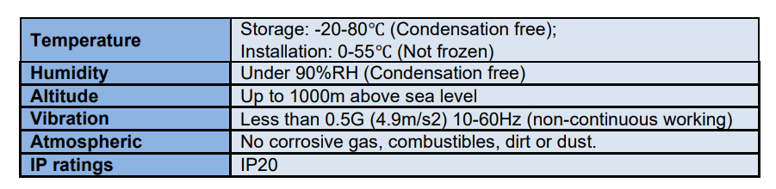

Servo drive dimension
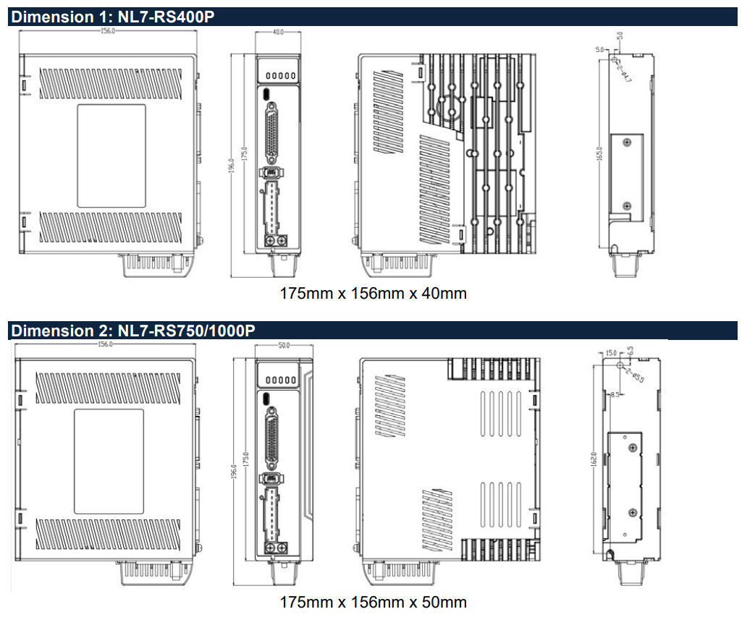
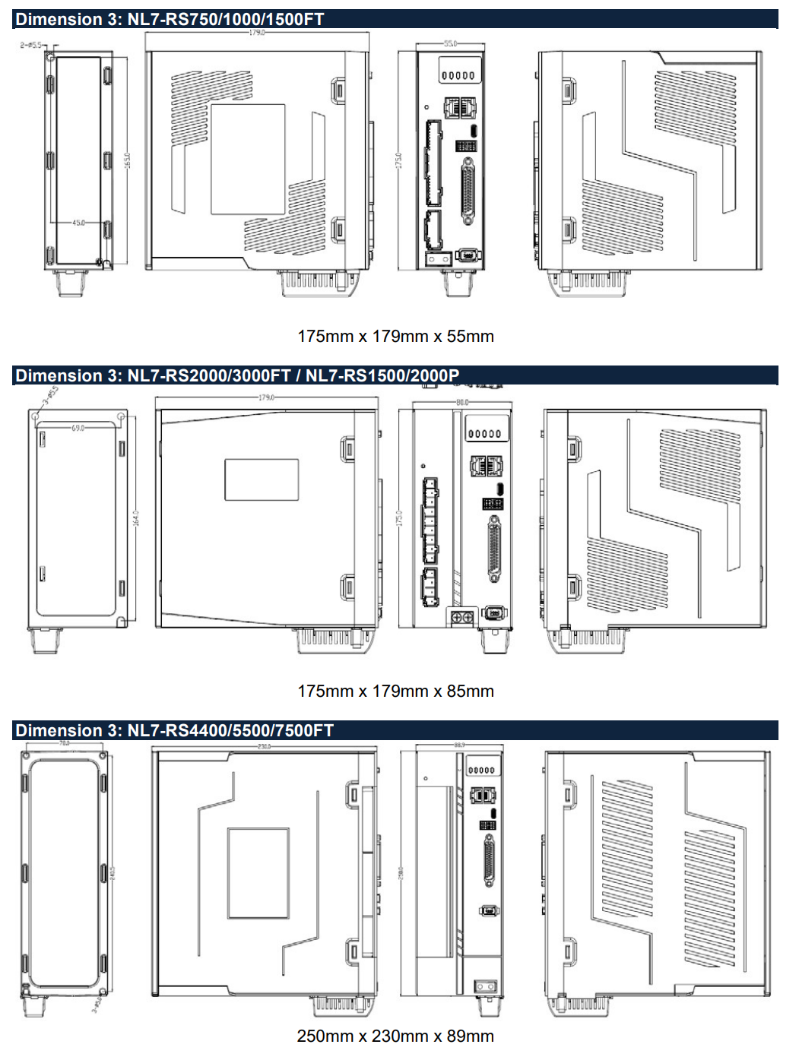

Space requirement for installation
In order to ensure efficient heat dissipation, please leave at least 10mm installation space in between drivers. If drivers need to be mounted compactly, please leave at 1mm of installation space. Please keep in mind that under such conditions, the drivers can only run at 75% of actual load rate.
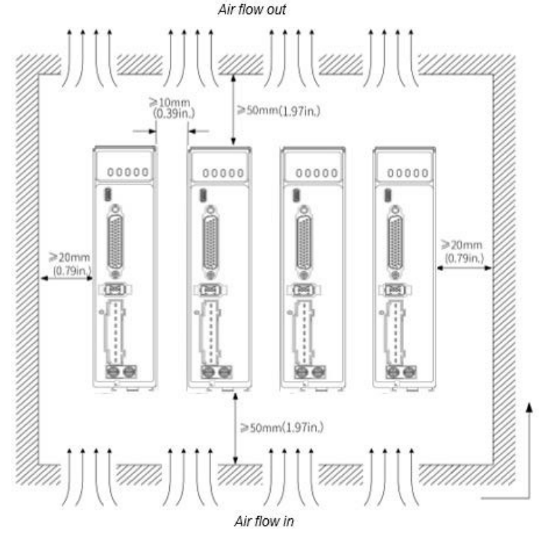

Installation method
Please install the driver vertical to ground facing forward for better heat dissipation. Always install in rows and use heat insulation board to separate between rows. Cooling fans are recommended for drivers to achieve optimal performance.

Grounding
PE terminals must be grounded to prevent electrocution hazard or electromagnetic interference.

Wiring
Please ensure there is no liquid around the wiring and connectors as liquid leakage may cause serious damage to the driver(s).

RJ45 port cover
Please cover unconnected RJ45 port(s) on top of the driver to prevent dust or liquid from damaging the ports.

Battery kit
If there is a need for battery kit, please remember to leave a room in the electrical cabinet for it.

