Tracking mode

Configuration
in the application where there is the need to follow a speed synchronization (for example following a conveyour belt speed) adapting the cycle time, we have to use the Tracking mode. The parameter 1792 - Motion mode must set to 4 ⇒ Tracking - Following trigger. and the trigger mode of the two motion task must be set to DIG IN rising edge.
In this modality the motion cycle time will be calculated in function of the trigger period detected on the Digital Input 1 during motion..When the trigger frequency increases or decreases the motor will adapt the motion cycle time consequentlly.
The parameter 1790 displays the calculated tracking speed during motion.
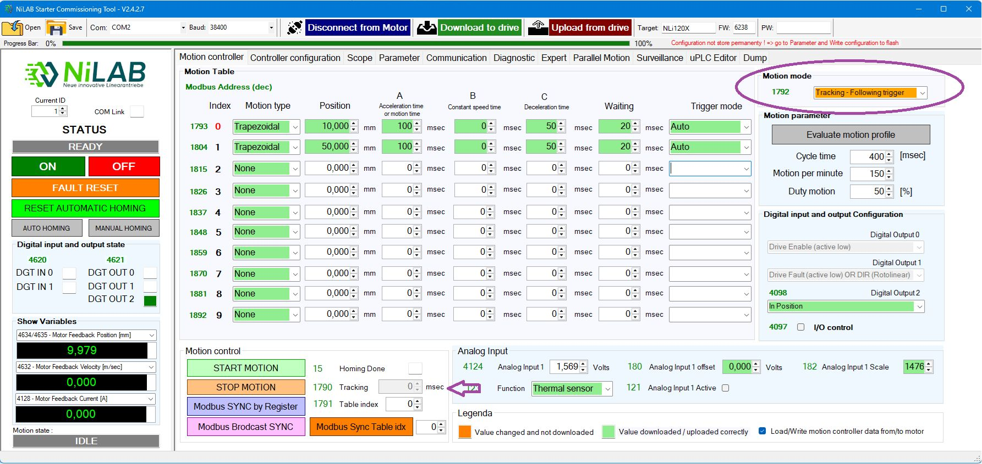tracking_conf.jpg

Limitation
The FIrmware version must be >= 5E39 and NiLAB Starter version must be >= 2.4.0.2
The table specified waiting time is not considered in the cycle time but a standard waiting time of 50 msec is used to guarantee the synchronization from the trigger input.
The waiting time can be modified using the parameter 185 inside the parameter window.
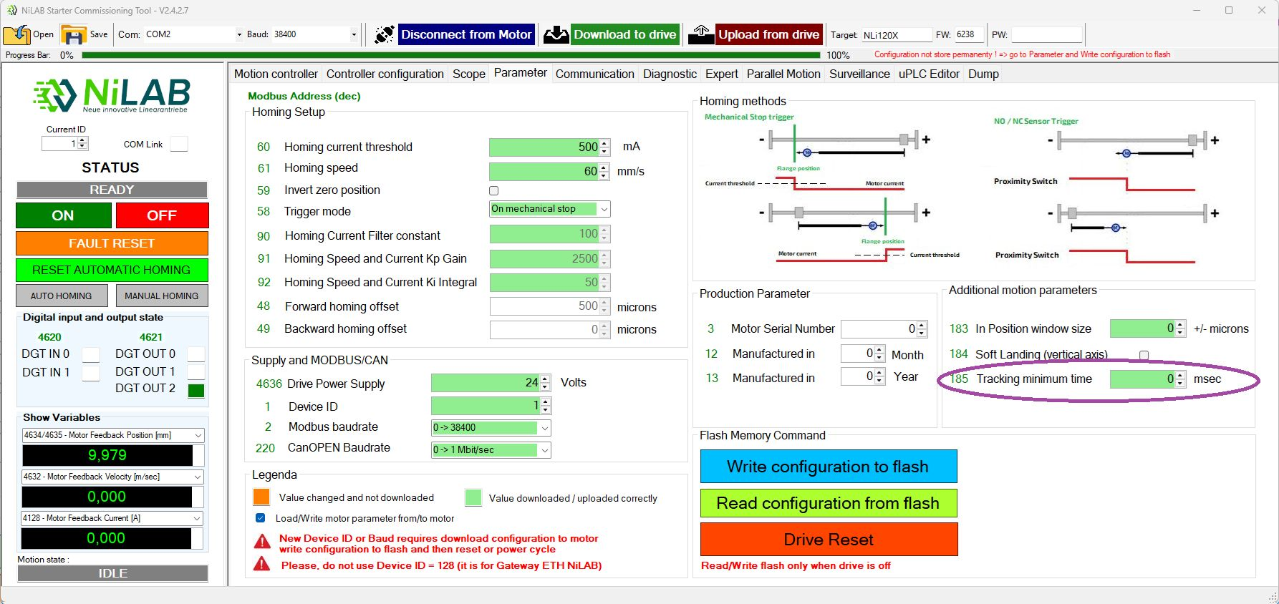tracking_min_time.jpg

Video Demostration

