Options

Over Current Detection (OCD)
OCD unit monitors the status of current at all times. When it reaches stroke limit or encounters any blockage on its way, the OCD unit shuts motor down proactively to prevent it from burning out.
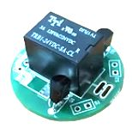

Anti Pinch With Load Setting
Set up the max. load based on your demand to make it work smarter. For instance, to lift an object weights 15kg, an actuator with preset max. load 20kg reserves 5kg allowance to activate anti pinch function.

Stroke Setting, Work With Switches.
Sometimes the existing product does not fit perfectly with your demand. For example, you could hardly find an actuator with stroke 170mm from the market but that is what you actually need.
Not a problem, just connect our actuator with external reed switches, adjust the stroke, and everything is done.
Function S: Stroke setting, 2 sets of wiring (4 wires) total for the upper and lower limits. It can be connected to your own A-contact switches, such as reed switches, limit switches, push switches, tact switches, etc.
Function R: With built-in reed switches and a magnetic ring, the position of movement can be sensed to stop at any position.
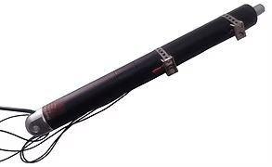

Hall Sensor for Accurate Positioning.
Function H: With a built-in hall sensor, positioning signals could be retrieved to your PLC for dedicated relative positioning.
A Hall sensor is a type of sensor which detects the presence and magnitude of a magnetic field using the Hall effect. The output voltage of a Hall sensor is directly proportional to the strength of the field.


