MEQI Ballscrew actuator
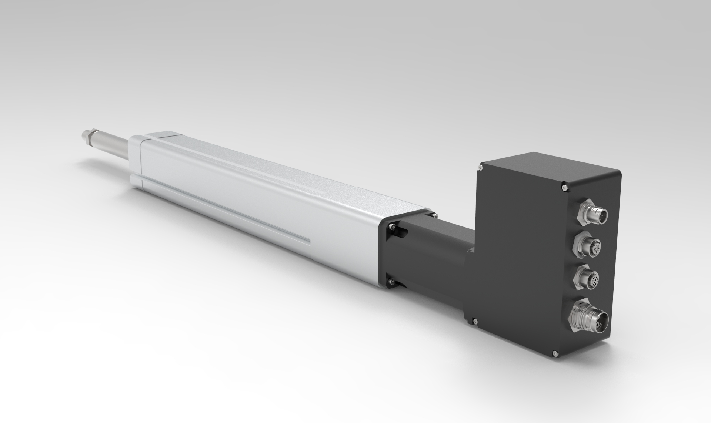
MOTOLAB GmbH, a company controlled by NiLAB GmbH (Austria) and Motus-tech srl (Italy) offers integrated BLDC motors combined with ballscrew actuator in different sizes and with a rated power upto 900 W combined with different ballscrew actuator flanges. Due to their excellent dynamic performance, these smart brushless DC servos actuator are ideally suited for applications with fast acceleration, such as in medical engineering, automation, robotics or in special machine construction.
- Precise position, speed and torque control
- Magnetic single-turn absolute encoder
- Digital and analog inputs, digital outputs
- Integrated temperature monitoring to prevent overload
- Smooth running
- Long service life

