13bit SIN/COS Encoder converter - Interpolator

Overview
NL-NQ6D is an advanced interpolator for all kind of encoders with SIN/COS 1Vpp. This device with DIN rail mounting converts the SIN/COS 1Vpp analog signal into Quadrature Digital output AB with TTL 5V level output. Furthermore, it can also convert the SIN/COS 1Vpp analog signal into digital output BiSS-C or SSI. This is necessary when the servo-drive is not able to use directly the SIN/COS signal as feedback.
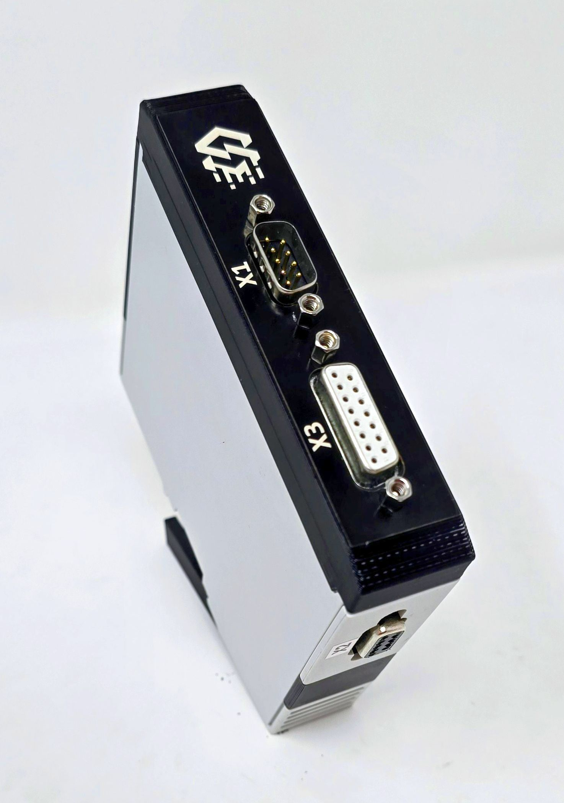interpolator_photo.jpg

Programming interface - Driver & Software
The interpolator can be programmed using programming cable DE23500555-1M in combination with programming software.
Programming cable windows driver can be downloaded here: :miniature_motors:usb_mb3u_driver_ftdi21224.zip
The GUI interface can be downloaded here: :miniature_motors:nqc_1so_gui_c8rte.zip

Features:
- 13 bit Interpolation with resolution up to 8192 angle steps per sine period.
- Binary and decimal resolution settings, e.g. 500, 512, 1000, 1024
- programmable angle hysteresis
- Conversion time of just 250 ns including amplifier settling
- Direct sensor connection; selectable input gain
- Input frequency of up to 250 kHz 6. Signal conditioning for offset, amplitude and phase
- A/B quadrature signals of up to 2 MHz with adjustable minimum transition distance
- Zero signal processing, adjustable in index position and width
- Absolute angle output via fast serial interface (BiSS, SSI)
- Permanent bidirectional memory access to parameters and OEM data by BiSS C
- Period counting with up to 24 bits
- Error monitoring of frequency, amplitude and configuration
- Device setup from serial EEPROM or using BiSS
- ESD protection and TTL-/CMOS-compatible outputs
- Ideal for all type of NiLAB Linear motors
The product is based on IC-Haus integrated circuits, please see datasheet for the full information: :green_drive_motors:nqc_datasheet_e2en.pdf

Connectors
X1 connector is male d-sub 9, X2 connector is female d-sub9, X3 connector is female d-sub 15.
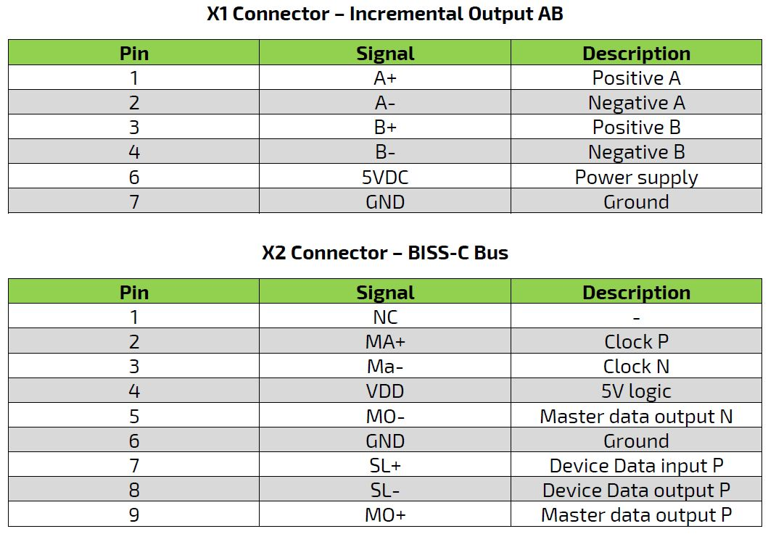nq6_1.jpg
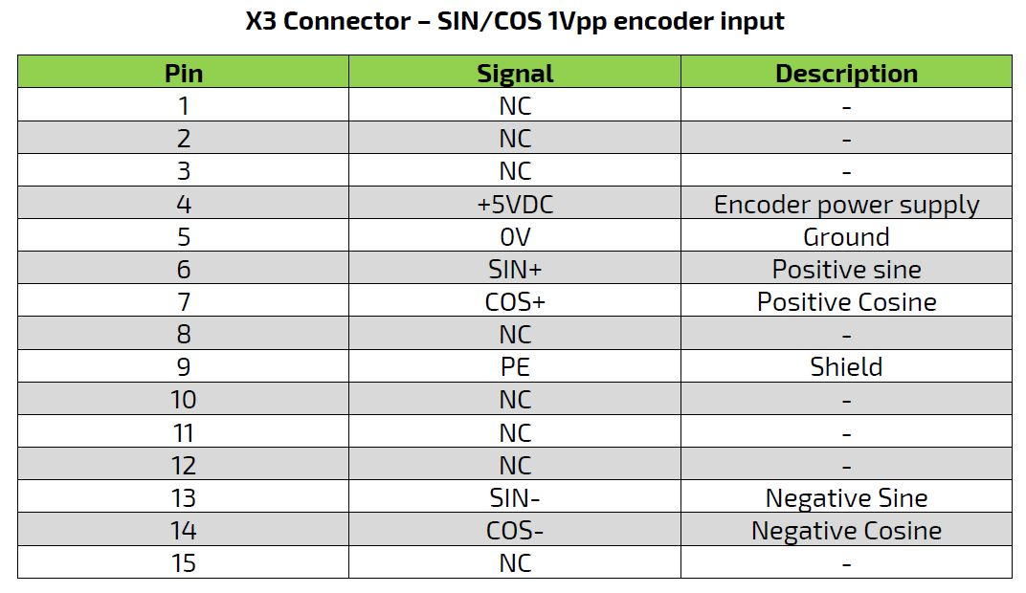nq6_2.jpg

Power supply

Using programming cable
When the programming calbe is used the power supply for Interpolator and the connected SIN/COS encoder can be provided
by USB (in this case check is the current will be enought for the correct ioperation) or with external 5V power supply connected
on the power X1.
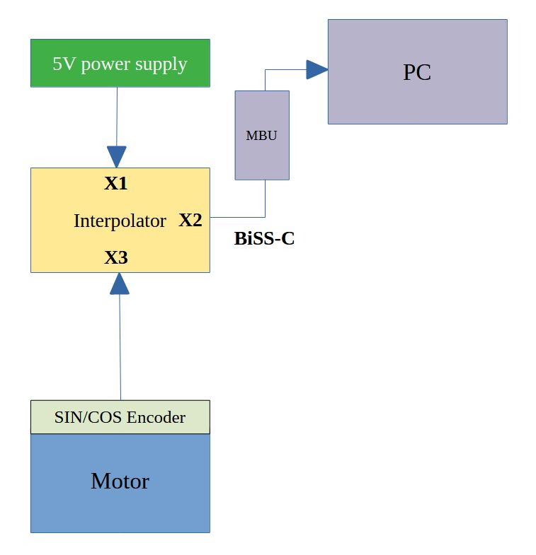connection_2.jpg

Using Servo Drive
Connecting a servo drive BiSS interface, the 5V power can be porvided by the feedback port of the servo drive or
using external 5V power supply connected on port X1.
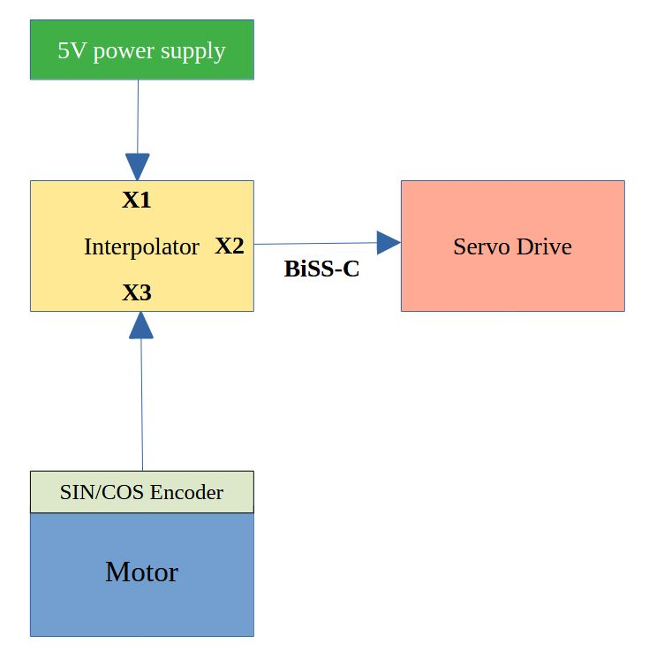connection_1.jpg
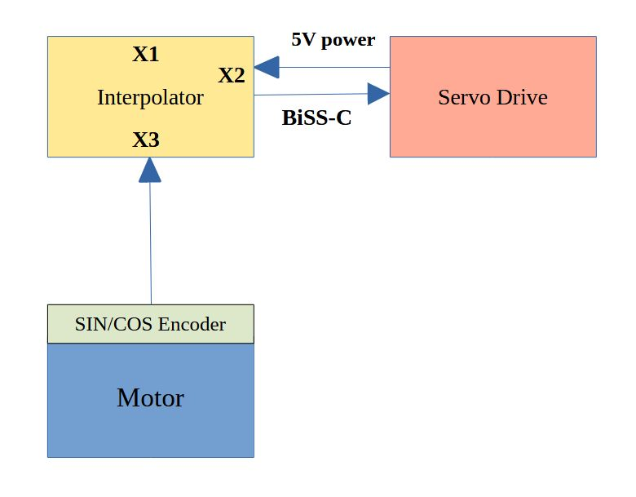connection_3.jpg

