Dimensional details
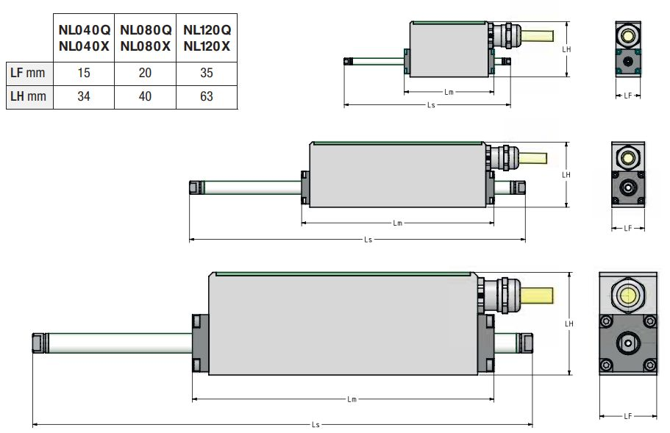miniature_1.jpg
DIMENSION | DESCRIPTION | NL040Q | NL040X | NL080Q | NL080X | NL120Q | NL120X | UNIT
LM | Motor length | 55 | 86 | 118 | 137 | 185 | 305 | mm

Stroke value in respect to slider codes / lengths

NL120Q/X
Slider code | Slider Weight  [Kg] | Total slider  Length [mm] | Usable slider  length [mm] | Stroke with  NL120Q [mm] | Stroke with  NL120X [mm]
NL120-G245 | 0,163 | 245 |  |  | -
NL120-G275 | 0,185 | 275 |  |  | -
NL120-G305 | 0,208 | 305 |  |  | -
NL120-G335 | 0,231 | 335
NL120-G365 | 0,254 | 365
NL120-G395 | 0,277 | 395
NL120-G425 | 0,299 | 425
NL120-G455 | 0,322 | 455
NL120-G485 | 0,345 | 485
NL120-G515 | 0,368 | 515
NL120-G545 | 0,391 | 545
NL120-G575 | 0,411 | 575
NL120-G605 | 0,432 | 605
NL120-G635 | 0,454 | 635
NL120-G665 | 0,475 | 665
NL120-G695 | 0,497 | 695
NL120-G725 | 0,518 | 725
NL120-G755 | 0,539 | 755
NL120-G785 | 0,561 | 785
NL120-G815 | 0,582 | 815
NL120-G845 | 0,604 | 845
NL120-G875 | 0,625 | 875
NL120-G905 | 0,647 | 905
NL120-G935 | 0,668 | 935
NL120-G965 | 0,69 | 965
NL120-G995 | 0,711 | 995
NL120-G1025 | 0,732 | 1025
NL120-G1055 | 0,754 | 1055

NL080QX
Slider code | Slider Weight  [Kg] | Total slider  Length [mm] | Usable slider  length [mm] | Stroke with  NL080Q [mm] | Stroke with  NL080X [mm]
NL080-G151 | 0,053 | 151
NL080-G181 | 0,063 | 181
NL080-G211 | 0,074 | 211
NL080-G241 | 0,084 | 241
NL080-G271 | 0,095 | 271
NL080-G301 | 0,105 | 301
NL080-G331 | 0,116 | 331
NL080-G361 | 0,126 | 361
NL080-G391 | 0,137 | 391
NL080-G421 | 0,147 | 421
NL080-G451 | 0,158 | 451
NL080-G481 | 0,168 | 481
NL080-G511 | 0,179 | 511
NL080-G541 | 0,189 | 541
NL080-G571 | 0,2 | 571
NL080-G601 | 0,21 | 601
NL080-G631 | 0,221 | 631
NL080-G661 | 0,231 | 661
NL080-G691 | 0,242 | 691
NL080-G721 | 0,252 | 721
NL080-G751 | 0,263 | 751
NL080-G781 | 0,273 | 781
NL080-G811 | 0,284 | 811

NL040Q/X
Slider code | Slider Weight  [Kg] | Total slider  Length [mm] | Usable slider  length [mm] | Stroke with  NL040Q [mm] | Stroke with  NL040X [mm]
NL040-G74 | 0,007 | 74
NL040-G9 | 0,008 | 92
NL040-G110 | 0,01 | 110
NL040-G128 | 0,012 | 128
NL040-G146 | 0,013 | 146
NL040-G164 | 0,015 | 164
NL040-G182 | 0,016 | 182
NL040-G200 | 0,018 | 200
NL040-G218 | 0,02 | 218
NL040-G236 | 0,021 | 236
NL040-G254 | 0,023 | 254
NL040-G272 | 0,024 | 272
NL040-G290 | 0,026 | 290
NL040-G308 | 0,028 | 308
NL040-G326 | 0,029 | 326
NL040-G344 | 0,031 | 344
NL040-G362 | 0,033 | 362
NL040-G380 | 0,034 | 380
NL040-G398 | 0,036 | 398
NL040-G416 | 0,037 | 416
NL040-G434 | 0,039 | 434
NL040-G452 | 0,041 | 452
NL040-G470 | 0,042 | 470
NL040-G488 | 0,044 | 488
NL040-G506 | 0,046 | 506

