Connection of motor and holding brake

Motor connections
The servo amplifier motor-holding brake connection must be done using shielded cable. The shield must be connected at both ends. One side must be connected to the case of the motor that must be connected to the ground network. The other end should be connected to C3 / 3 (PE) or directly to the case of the servo amplifier. The servo amplifier allows to automatically manage the electromechanical motor brake (if present)
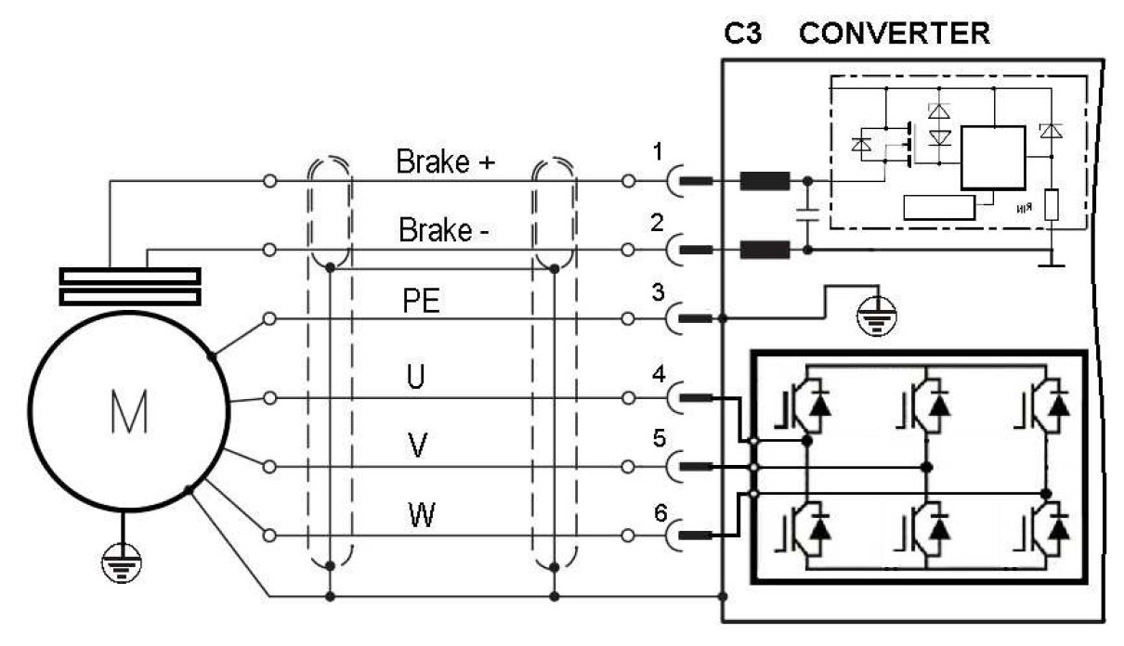motor_converter.jpg
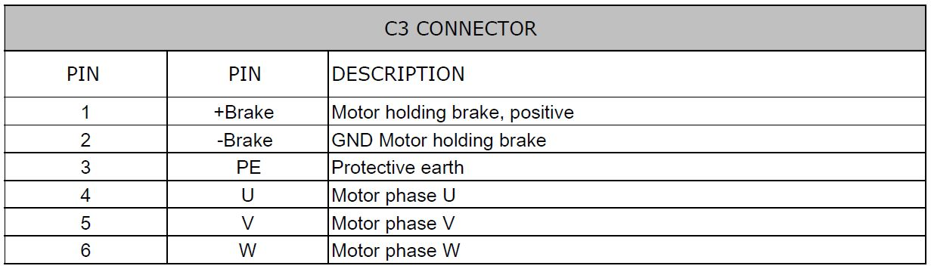motor_b1.jpg

Holding brake management
To enable the automatic management of the holding brake, set to value YES the menu “Mechanical Brake”, in the “Motor” window using TKSED software or MBD Studio software.
TKSED Software download: https://www.nilab.at/download/tksed-software-pc-tool/?wpdmdl=2126&refresh=637351b08fa4b1668501936
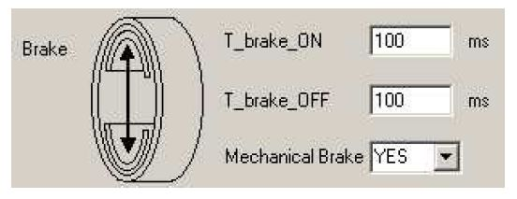motor_b2.jpg
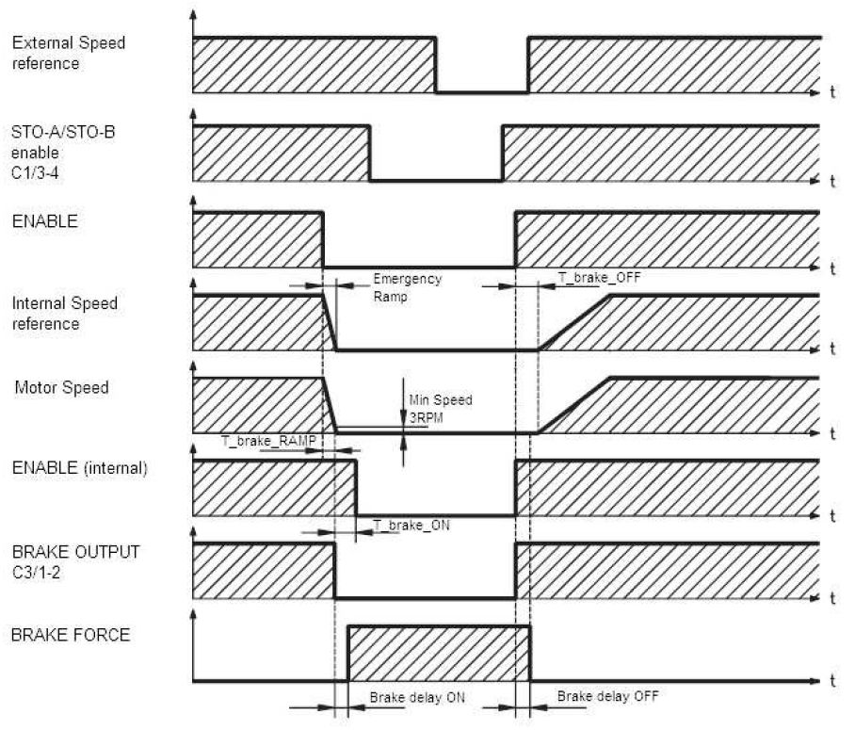motor_b3.jpg

