MBM Motors connections
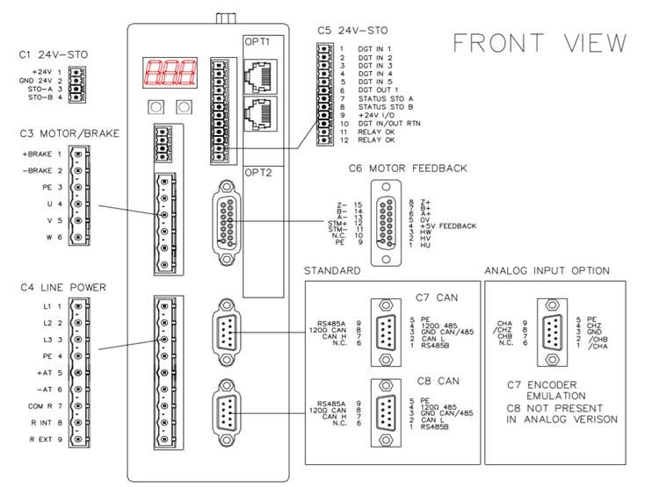mbm_motor_1.jpg
Please conisder the correct pinout in respect to the connector type shown below.
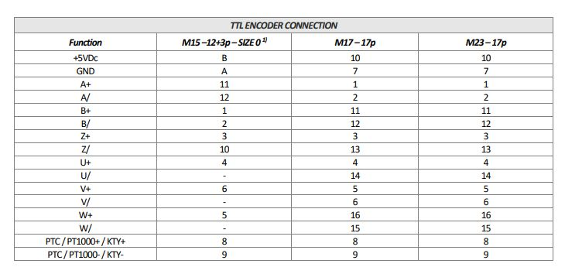mbm_motor.jpg

