Connection to 3-phases Mains Supply Networks

Connection with 3x400 VAC power lines
The connection of the main electrical supply is made via the C4 connector. The servo amplifier must be powered only by a 3-phase grounded current in the range 230V-10%, 400 +10% and 50/60Hz frequency.
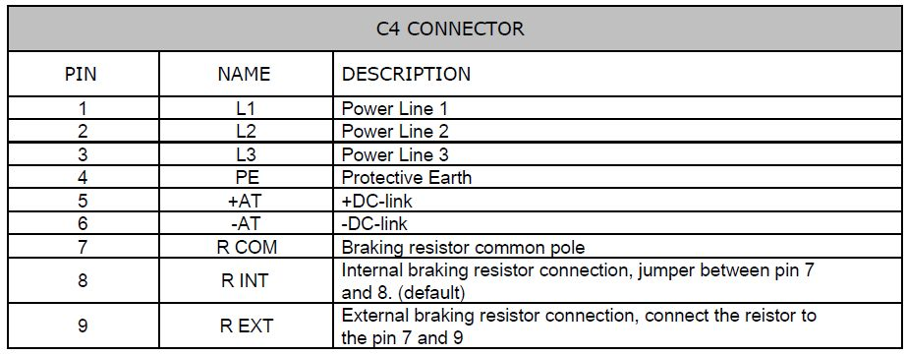main_1.jpg
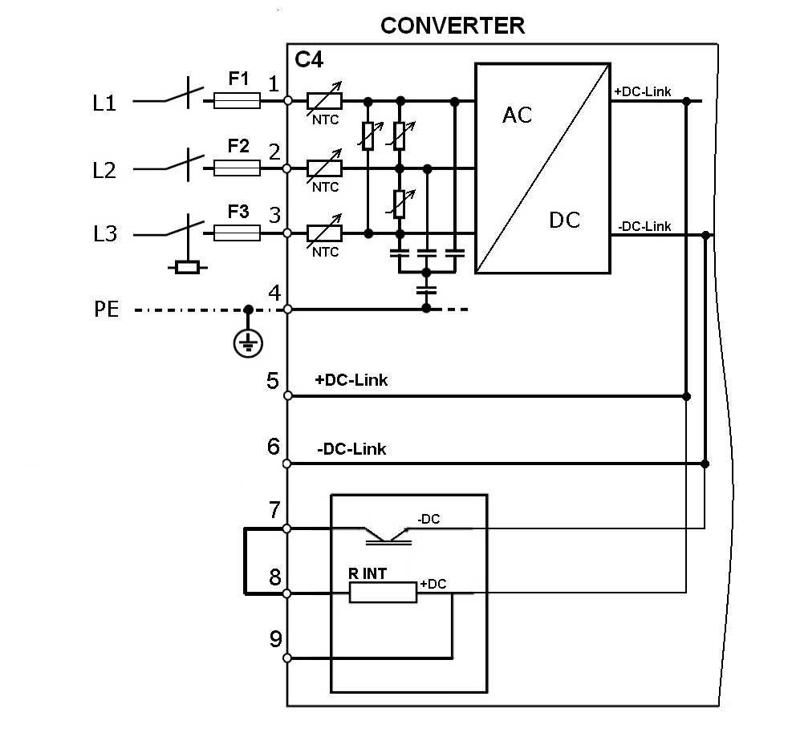main_2.jpg

Connection with 230VAC single phase powerline
Please note that if you would like to use with monophase 230VAC power lines you have to connect L1, L2 and PE.
Respectively, L1 (phase), L2 (neutral) and L3 (Protection earth).
Then set the right Supply values on the Basic Setup windon of TKSED software.


