Digital Signals

I/O Signals
The C5 connector has 5 digital inputs and 3 digital outputs. To these signals is added a differential analog input. All the digital inputs are optically isolated and all have in common a pole (DGT-IN-RTN) which acts as a return; normally is protected by grounding connection. Even for the digital outputs one of the poles is in common for all (see figure on the C5 connector).
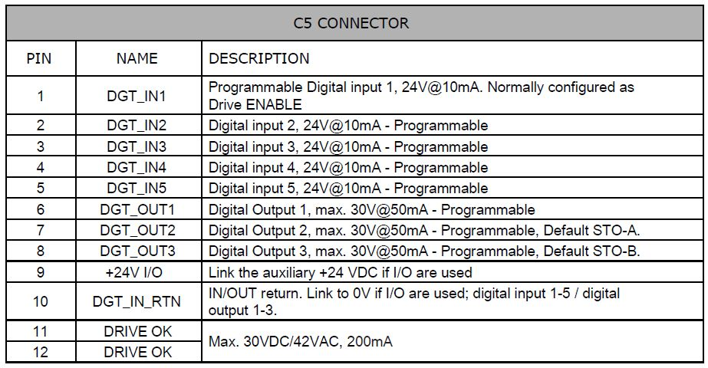io_signal.jpg

Digital Input schematics
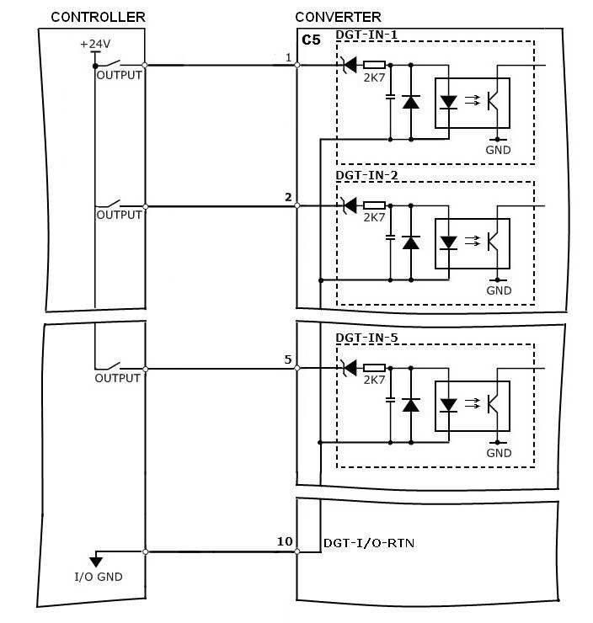dig_input.jpg

Digital Output Schematics
The servo amplifier supplies 3 programmable digital outputs. All outputs are protected against overvoltage and overcurrent.
A dedicated output, called relay Ok, provides a clean contact. In the start sequences you have to take account of the Relay OK contact.
After the auxiliary power supply +24 V to pin C1/1-2 is provided, the servo amplifier makes a check, if there aren't abnormalities the C5/11-12 Relay OK contact is closed allowing the system controller to provide the main power on C4/1-2-3.


