Accessories for mounting

Maglift 12/17/22 - Flange for slider
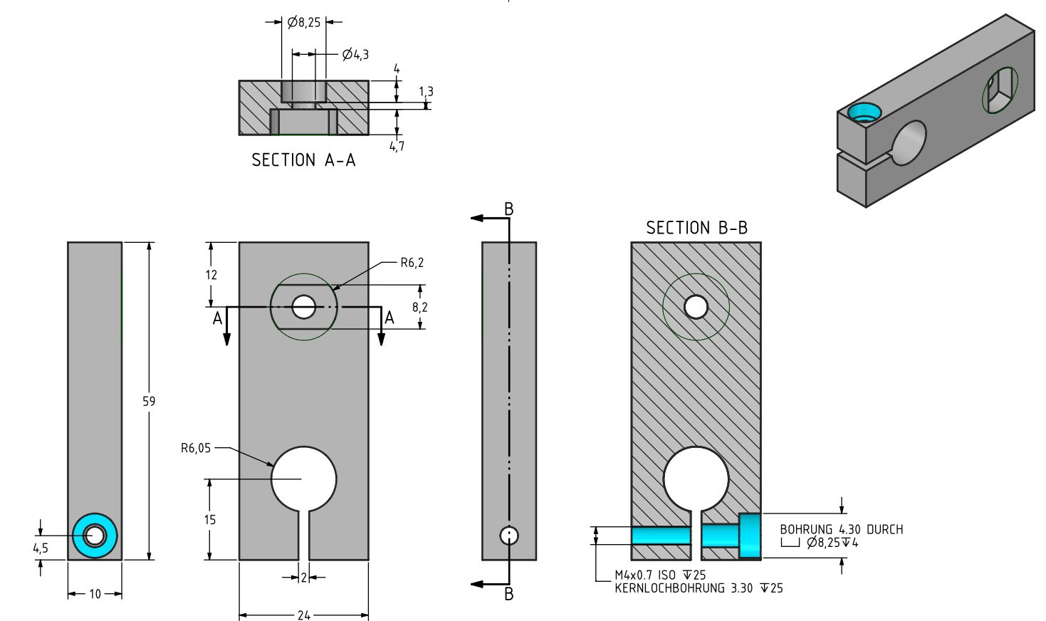f_ml_20_lf.jpg

Maglift 12/17/22 - Flange for stator
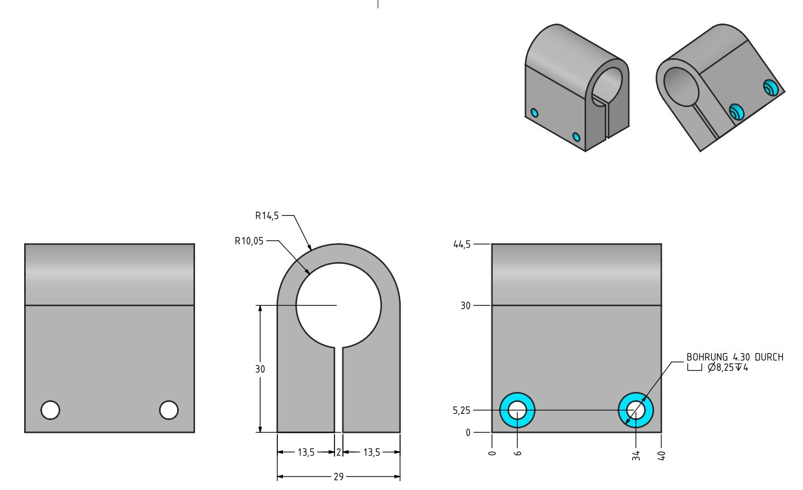f_ml_20_st.jpg

Maglift 40/50/60 - Flange for slider
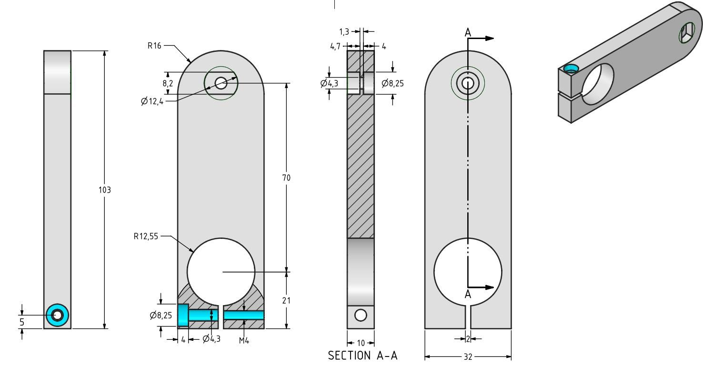

Maglift 40/50/60 - Flange for stator


