Force profile

Maglift 12/17/22
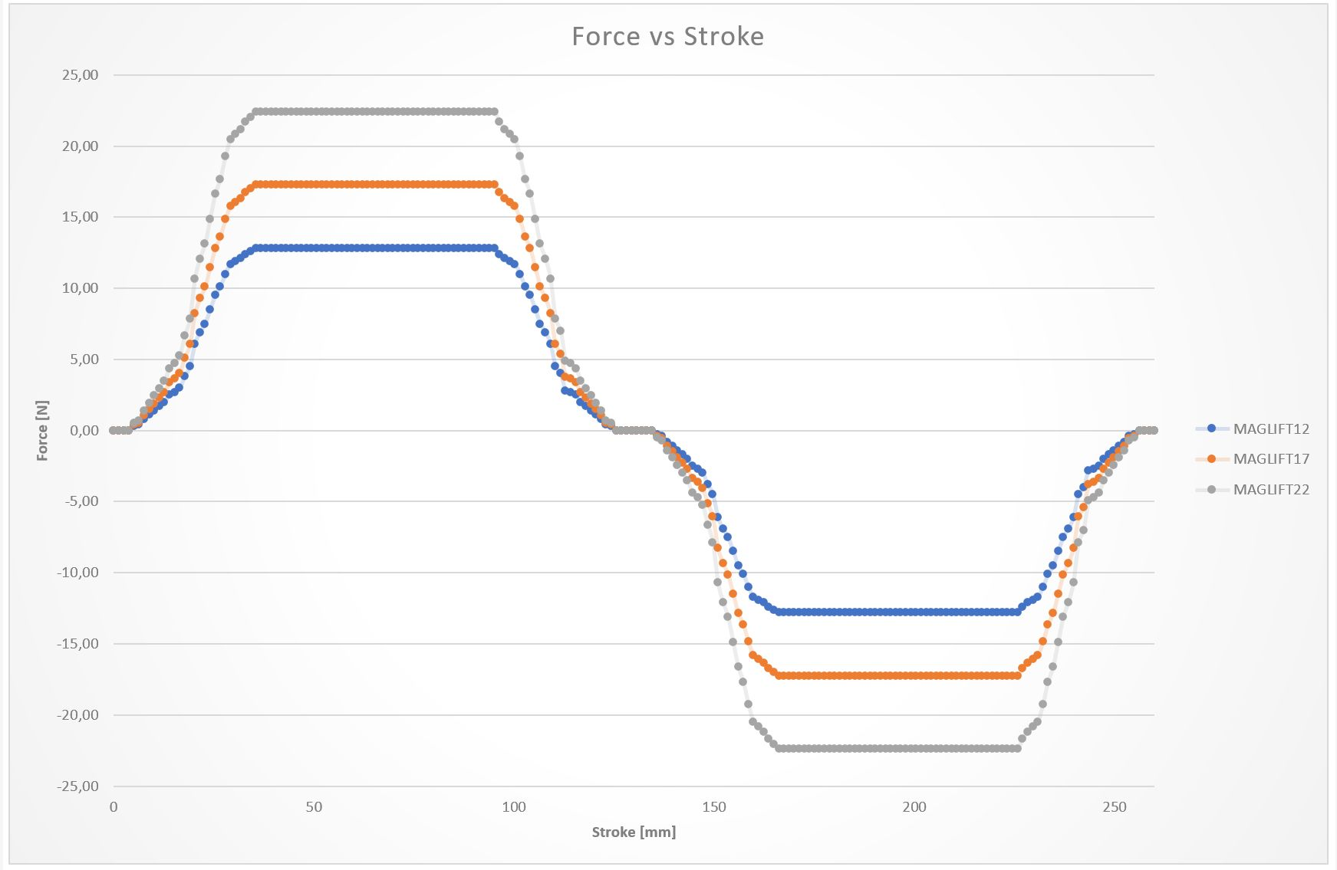force_12_17_22.jpg

Maglift 40/50/60


