Example of performance

Model : LMA150P-4815-100
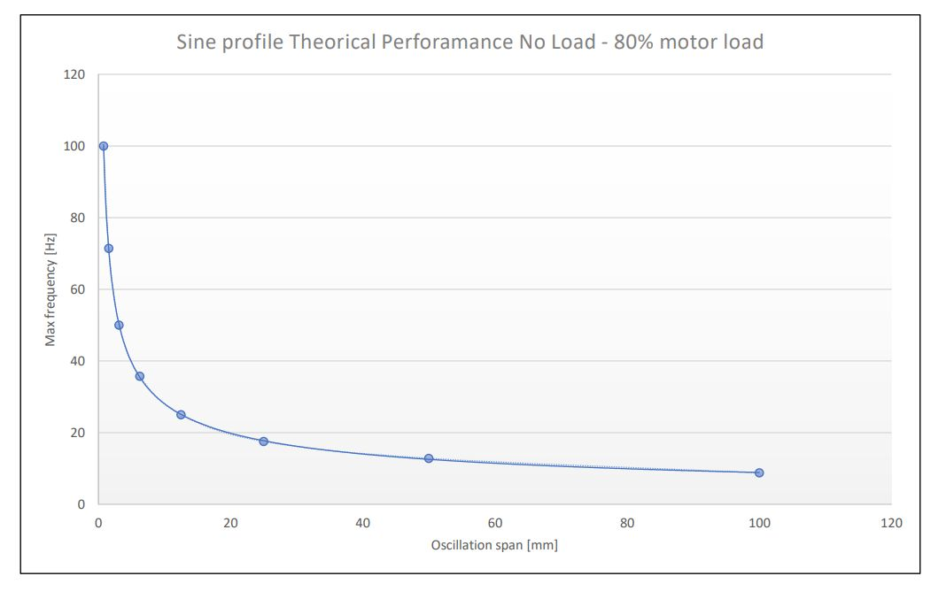perf.jpg
Parameter | Value
Peak force | 15400 N
Rated force | 7200 N
Moving mass of the actuator | 52 kg
Max stroke | 100 mm
Max acceleration | 30,2 Gs

