Cablechain option

CH - Horizontal mounting
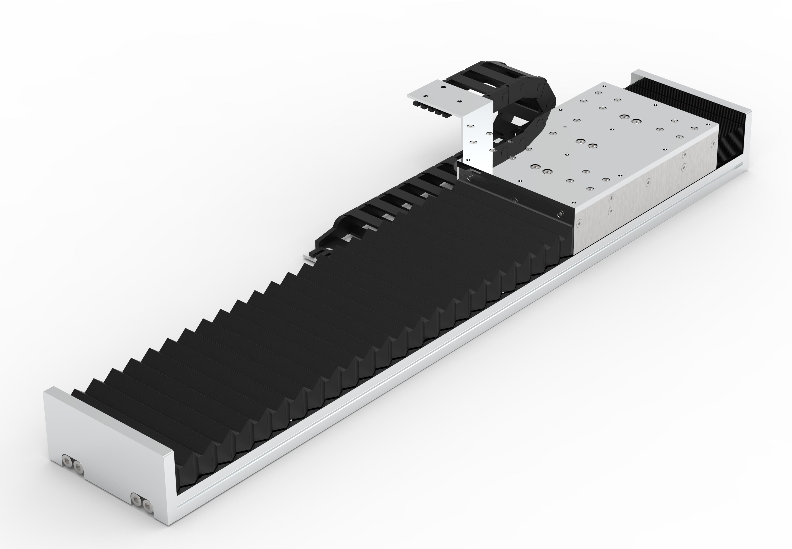ch_cable.jpg

CV - Vertical mounting
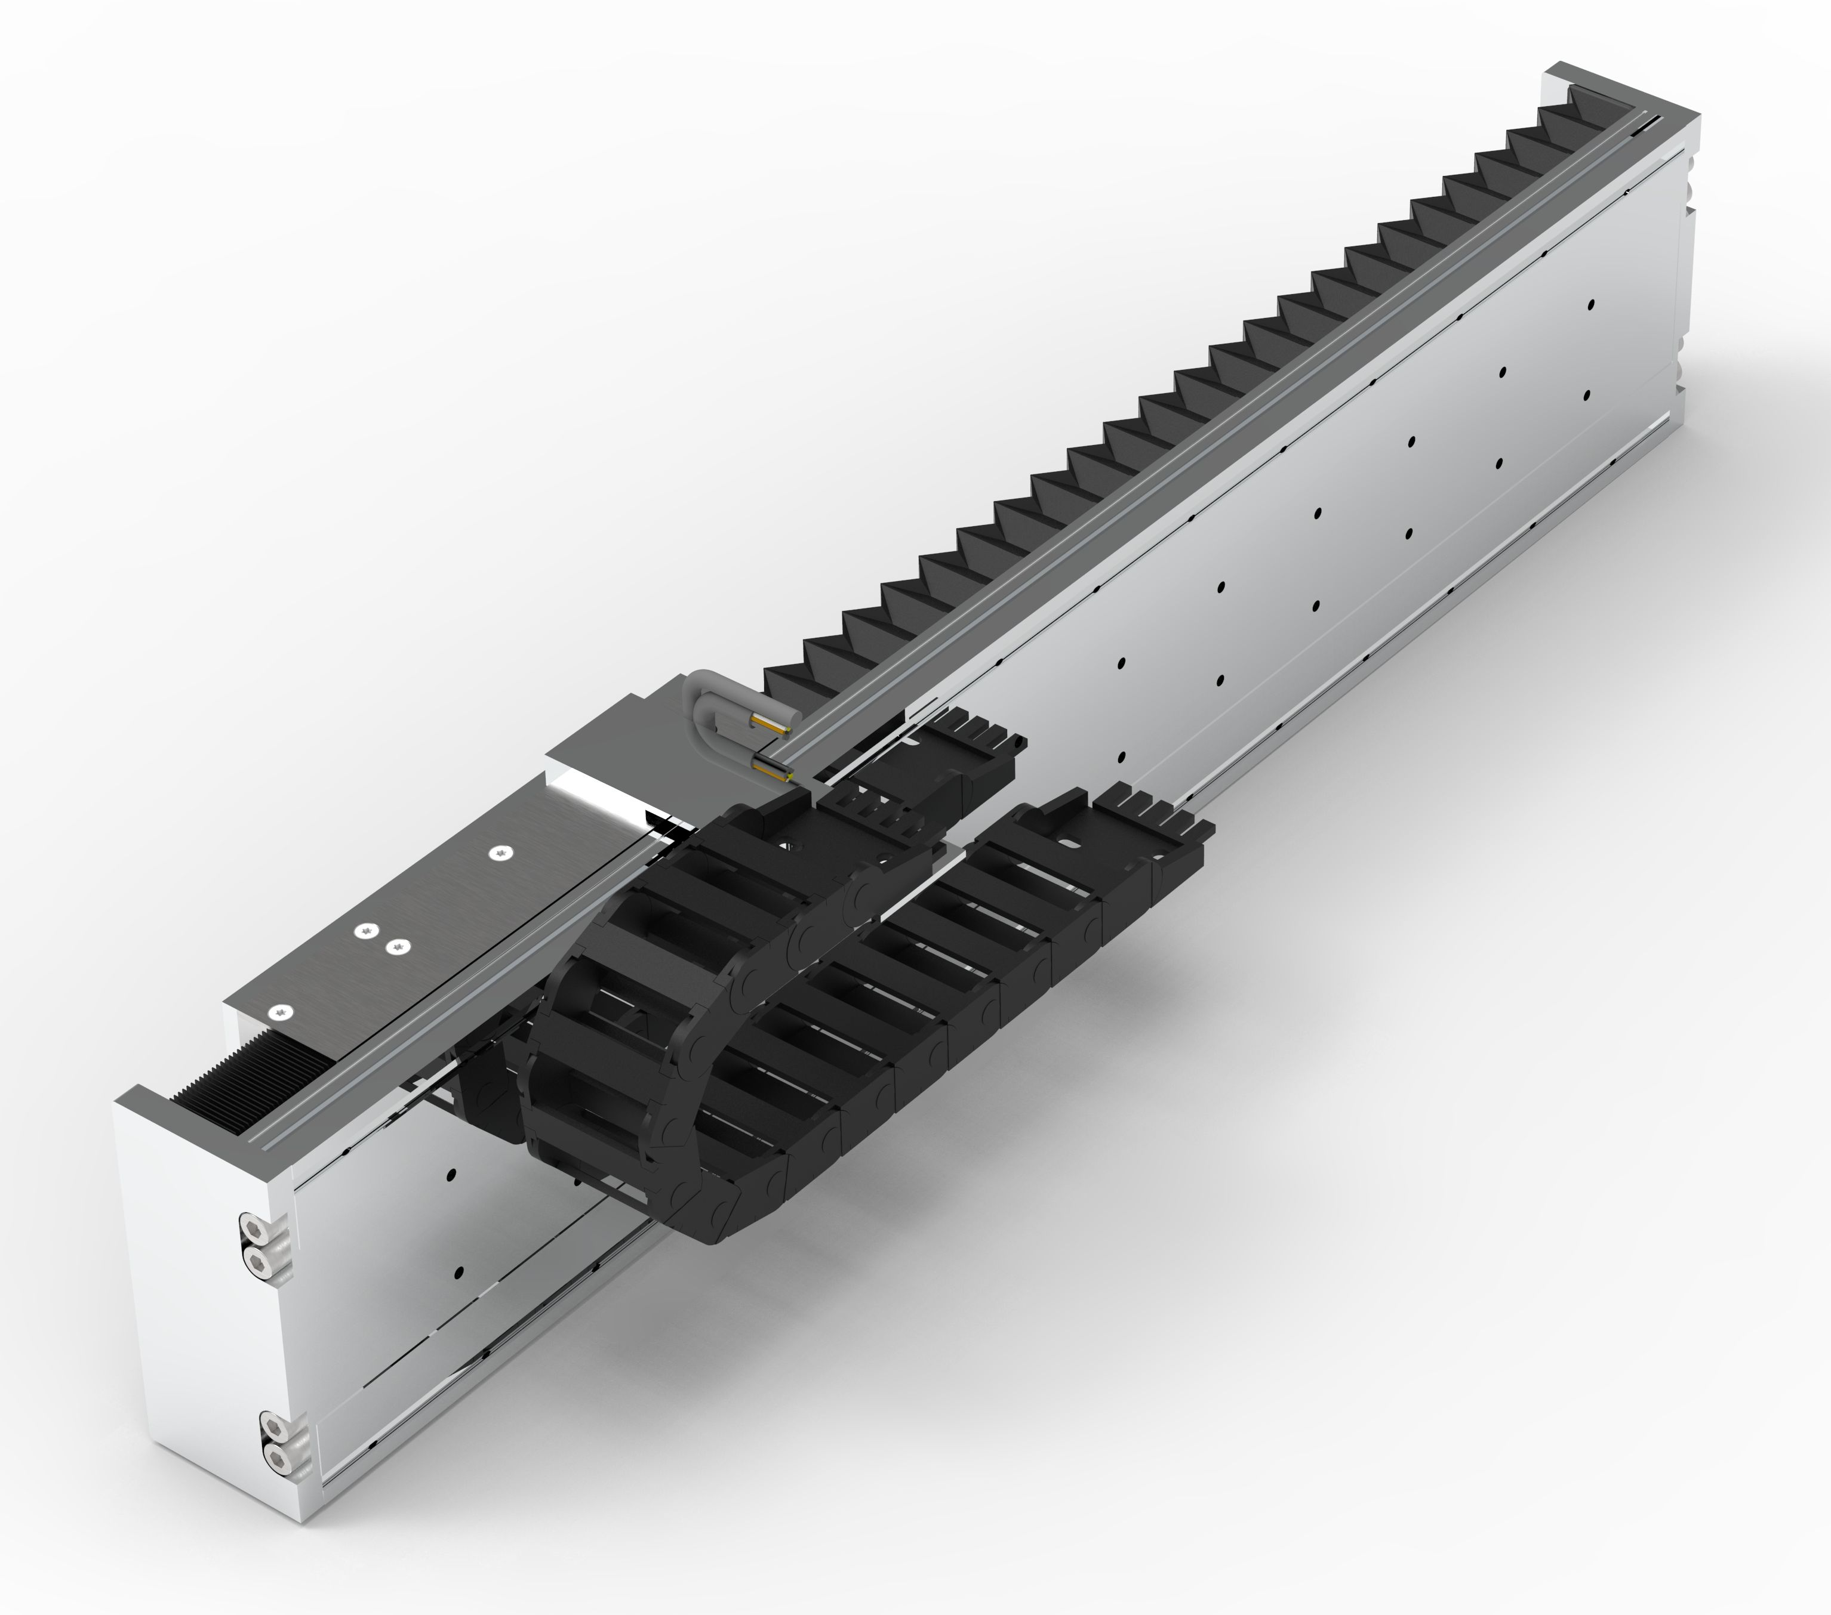cv.jpg

CS - Side mounting


