NLNS ironless Linear motors
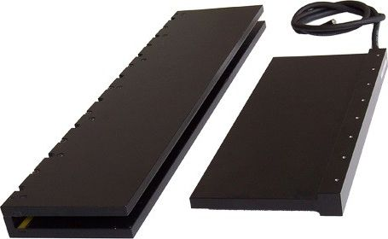nln_photos.jpg
Synchronous linear motors with a primary part without ferromagnetic materials The primary parts of these linear motors are characterized by low weight, practically zero attraction forces between the primary and secondary parts, high efficiency and the absence of traction force pulsations (cogging). Thanks to these properties, they can be advantageously used in dynamic applications demanding feed rate, acceleration, precision and low weight of the drive.
It is produced in sizes with peak forces of 80 to 1900N.

Features:
- High quality and production precision
- Suitable for highly dynamic applications
- Long service life and low operating costs

Demo video:

