NLiR Integrated Rotolinear motors

Integrated miniature rotolinear motor NLiR120Q/X
The Rotolinear NLiR integrates in one mechanical arrangement a miniature integrated drive linear motor and a coreless integrated drive brushless rotary motor. With this combination of technologies, you can create rotation combined with linear movements.
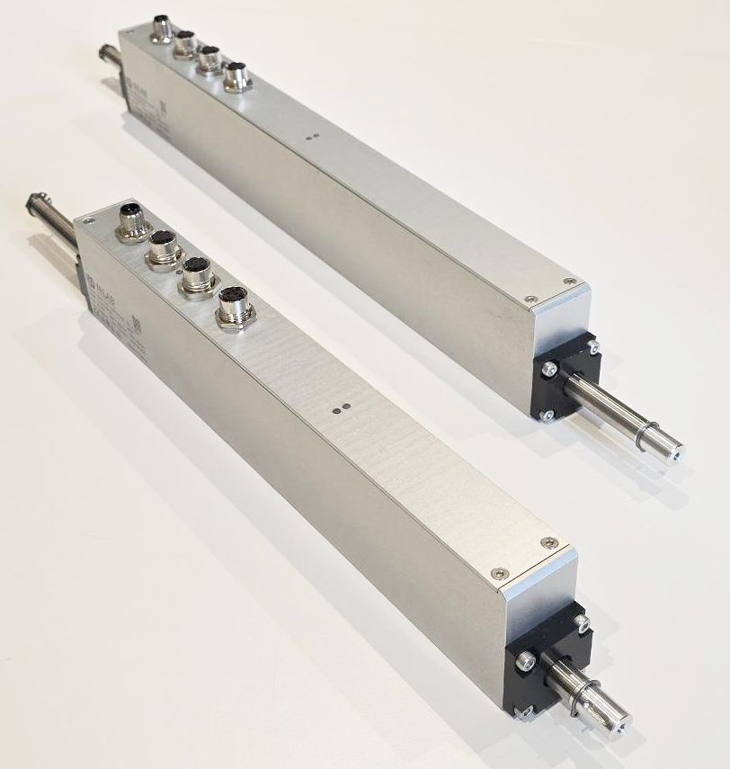rotlinear_motor_photo.jpg
Each of these motors can be controlled separately and in interpolation to realise applications such as capping and Pick & Place with rotation using integrated positioning table or by CanOPEN fieldbus.
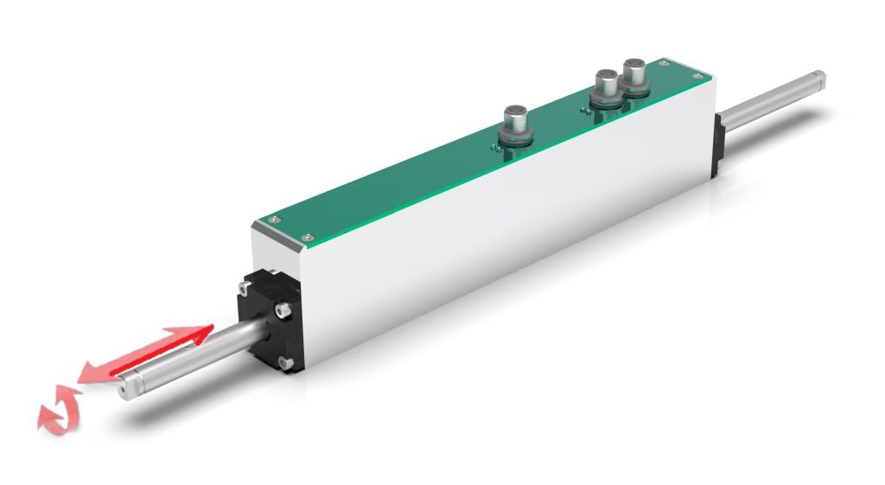rotolinear_integrated.jpg

