Installation

NLiR120Q-100-1 Fixing points
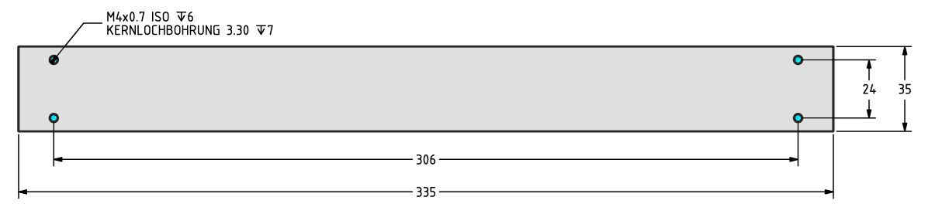nlir120q-100-1_fixing.jpg

NLiR120Q-100-2 Fixing points
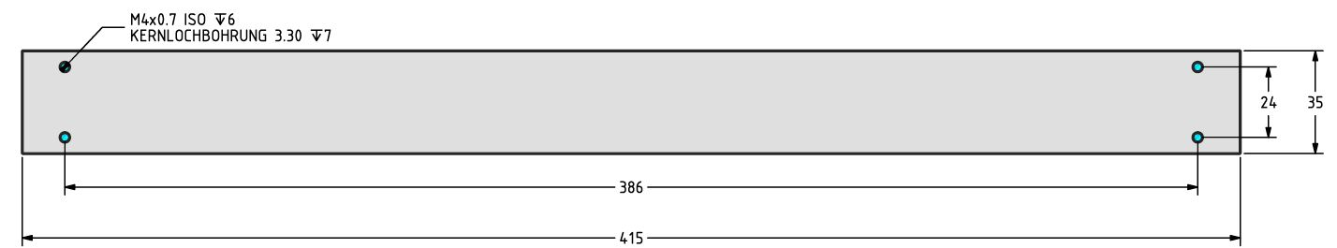nlir120q-100-2.jpg

Load coupling on the rotary side
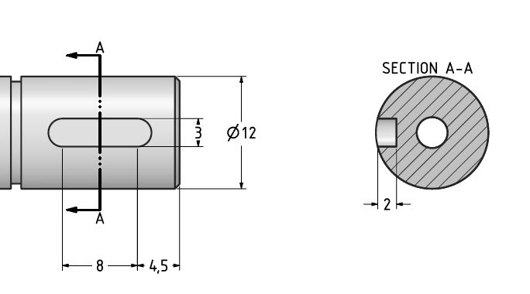coupling_nlir.jpg

