Dimensional details NLiR120Q
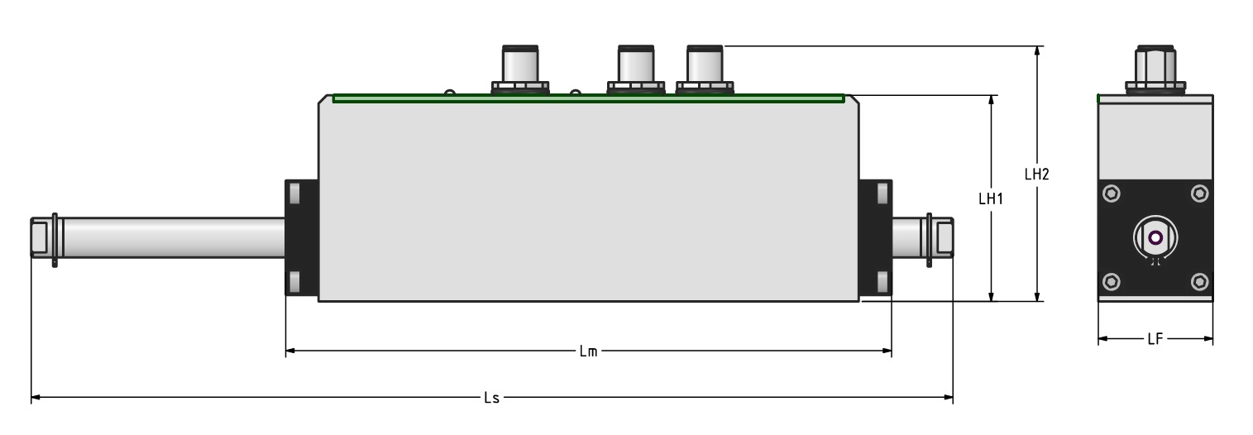
DIMENSION | DESCRIPTION | NLiR120Q-50-1 | NLiR120Q-50-2 | NLiR120Q-100-1 | NLiR120Q-100-2 | UNIT
LF | Flange width | 35 | 35 | 35 | 35 | mm
LH1 | Motor height without connectors | 63 | 63 | 63 | 63 | mm
LH2 | Motor height with connectors | 78 | 78 | 78 | 78 | mm
LM | Motor length | 305 | 400 | 358 | 438 | mm

