Startup and operation
In order to starup the motor and configure for machine operation, please refeer to NiLAB Starter documentation. NiLAB Starter is a Windows based PC software for programming and configuring the integrated drive linear motors.
This software can be downloaded here : https://www.nilab.at/dokuwiki/doku.php?id=nilab_starter:start

How to connect and program the motor using PC using programming cable - DA012060
see the info about the connections here: https://www.nilab.at/dokuwiki/doku.php?id=integrated_drive_motors:prog_box
see the video tutorial here: https://www.nilab.at/dokuwiki/doku.php?id=nilab_starter:video_tutorial
In order to program the intergrated linear motor using NiLAB Starter sofwtare you need the programming cable DA012060. This cable convert the USB to RS232/RS485. The programming cable is provided with a connector box copatible with connectors used with NLI080Q/X and NLi120QX.
First step is plug the USB cable into the PC and see what is the related COM port using the Windows Device Manager. For example here COM7 correspond to USB to RS232/RS485 programming cable.
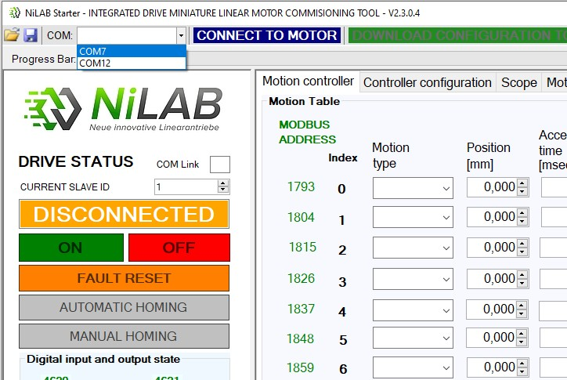nilab_starter_com_selection.jpg
Then, you have to select the right one on the combobox list in the NiLAB Starter Software and then press the button “Connect to Motor”.

How to connect and program the motor using PC using USB to RS485 with two motors
Please note that the two motor must have different ID Nodes values (Parameter 1)
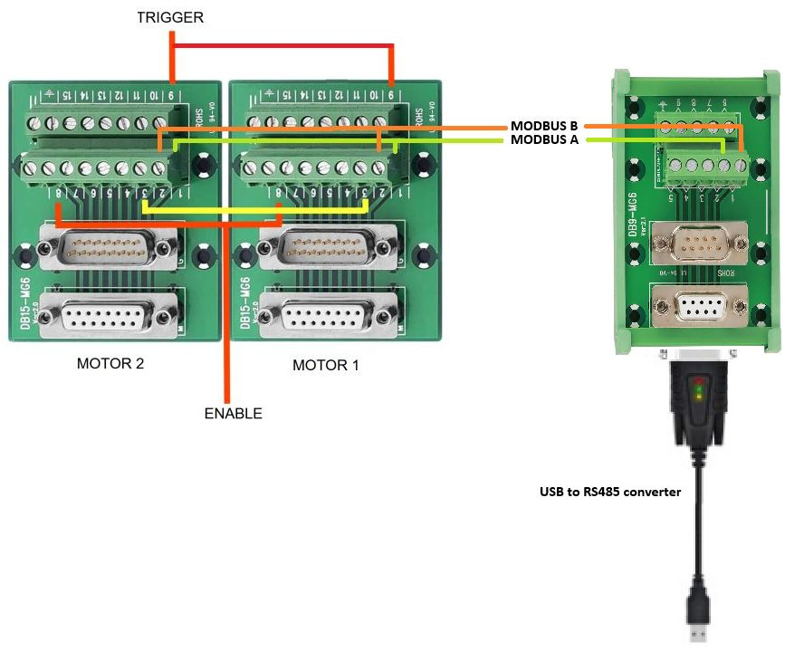modbus_to_pc.jpg

