PLC Control of 2 motors with synchronization
In order to control 2 motors in parallel and synhronized way, following the schema below (this example is using NiLAB NL-DB15-MG6 terminal blocks provided by NiLAB)
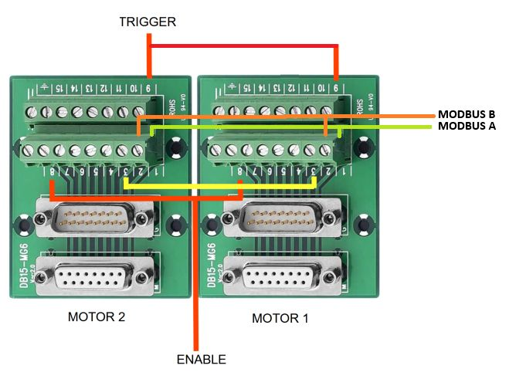2_motors.jpg
In the case of use of 2 x NLi080Q/X linear motor please connected the Pin 4 and Pin 5 to 24VDC and Pin 6 and Pin 7 to GND on each motor terminal blocks.
For a complete PIN description see here:https://www.nilab.at/dokuwiki/doku.php?id=integrated_drive_motors:connection_system|
2 outputs line must be provided from the PLC: Enable and Trigger. These are 24VDC level signals used to Enable (Pin 8 of each motor, first enable from power cycle automatically starts the homing procedure) and Trigger (Pin 9 of the two motors). In order to communicate using MODBUS RTU bus the Pin 1 and Pin 2 must be connected in parallel to the PLC modbus port.
Please make sure that the two motors on the MODBUS have 2 different MODBUS Address (ID Node) before connecting the MODBUS lines together.
The parameter to chage is: Parameter 1 Device ID in the Parameter window inside NiLAB Starter software.
MOTOR 1  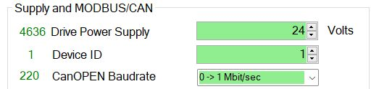modbus_2.jpg | MOTOR 2  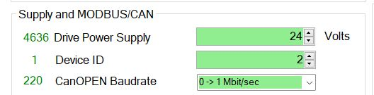modbus_1.jpg
Then, select on each motors the option I/O control - Parameter 4097 in Motion controller window of NiLAB Starter software.
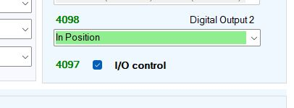io_control.jpg
Finally, set the Trigger mode in each motors to synchronize the two motors motion, for example at every rising edge of Digital Input 1.
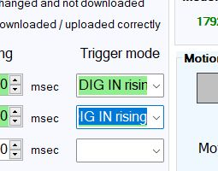trigger.jpg

