Master and slave mode
when two or more axis must be syhncronized without PLC that send a trigger signal on digital input 1, one NLi motor can be used as a master to synchronized the others.

Connection between the two motors
Pin 12 (Digital output 2) of the master motor must be connected to Pin 9 (Digital Input 1) of slave motor
Pin 8 (Digital input 0) must be set to 24VDC to start the motion.
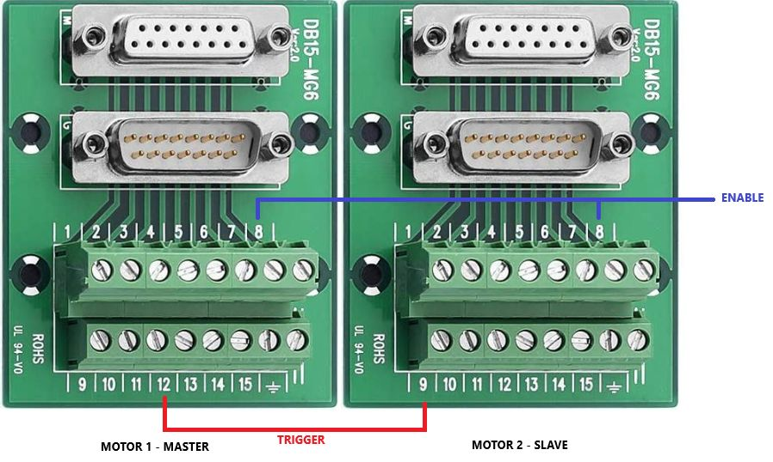master_slave.jpg

Example of configuration of the two axis
The waiting time of the master and slave must be set to a waiting time of 5 msec (1). On the master motor, the paramter 4098 Digital Ouput2 must be select to Master synch (2).
As regards the homing speed, please specify low speed (for example 10mm/sec) in the master motor and medium speed (for example 50mm/sec) in the slave motor.
This to guarantee that the automatic homing of the slave is completed before the master motor starts the motion.

Master configuration
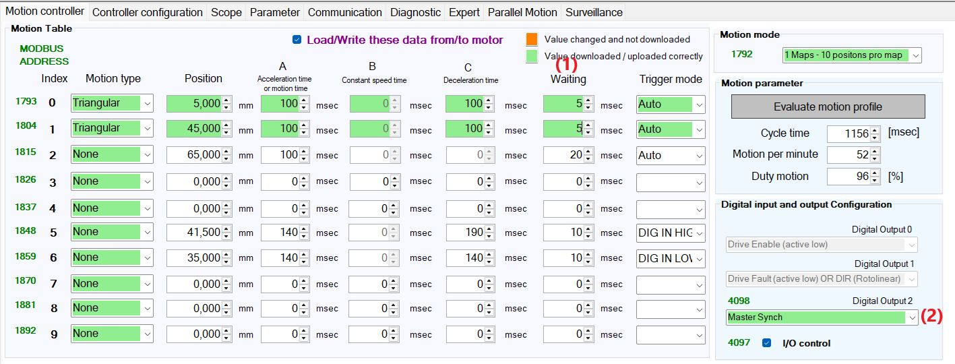master_config.jpg

Slave configuration
Trigger mode of the index 0 (first row) must be set to DIG IN falling edge (1) with a waiting time of 3msec and the parameter 4098 Digital output2 must be seto to In position (2)
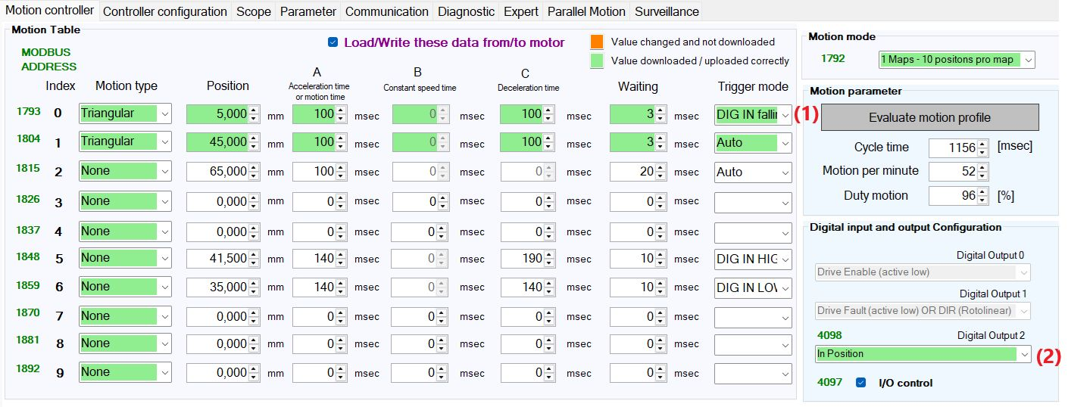slave_config.jpg

