Demo Case

1) NLi080Q Democase without PLC
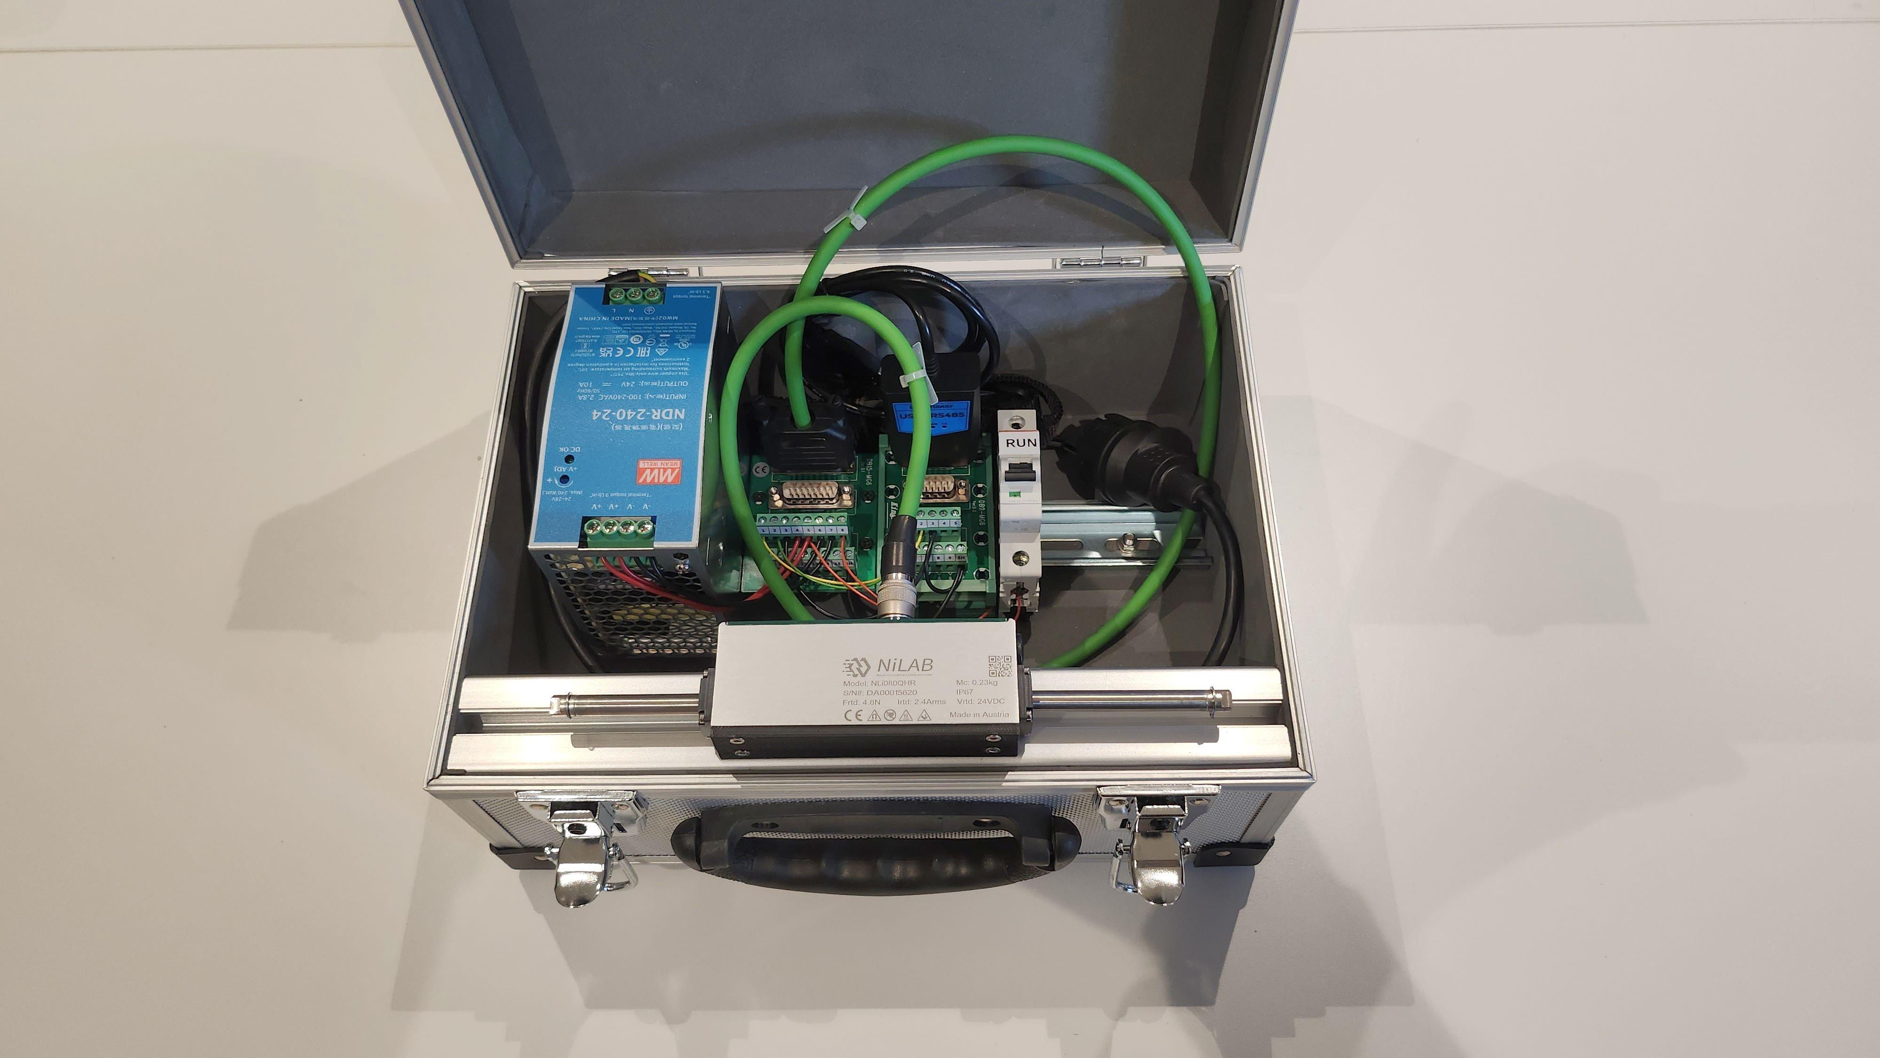demo_case_nli080.jpg
- NLi080Q-112-HR integrated drive linear motor, stroke 112mm
- Motor_cable DA00002011 (3 meter long)
- DIN RAIL 24VDC Power supply 230VAC 10Amps
- DIN RAIL NL-DB15-MG6 Terminal block
- DIN RAIL NL-DB9-MG6 Terminal block
- Programming cable DA012060
- Aluminium case 32.5 x 25.5 x 17.5 cm with Neoprene Lining and Carry Strap - Black
- ON switch

Democase video

2) NLi120Q and MCSS080X Democase with Raspberry PLC and Touchpanel
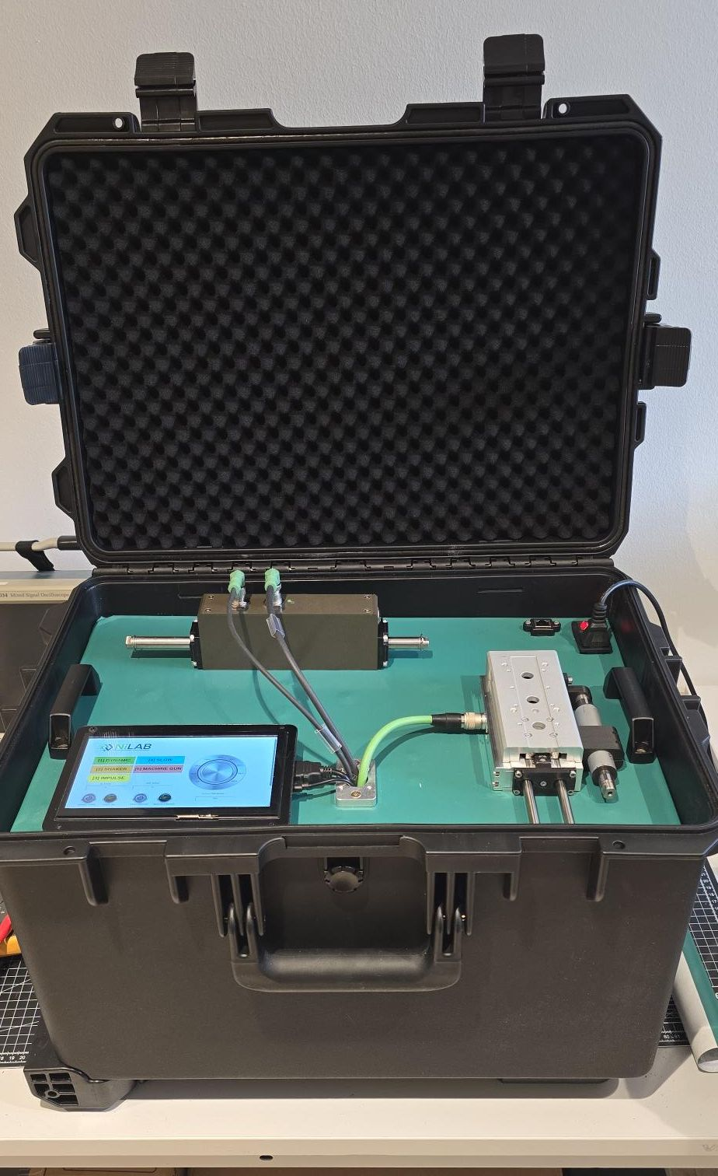demo_case_2.jpg
- NLi120Q integrated drive linear motor with GHA
- MCSS080X integrated drive linear guide
- Touch display
- Raspberry Pi3B PLC with codesys
- 24VDC 20A power supply
- 1 x DA00022011 power cable
- 1 x DA00002011 motor cable
- 1 x DA00012011 signal cable
Democase video

