Connections - NLi080Q or NLi080X

CANOPEN and MODBUS RTU - DOUBLE CONNECTOR
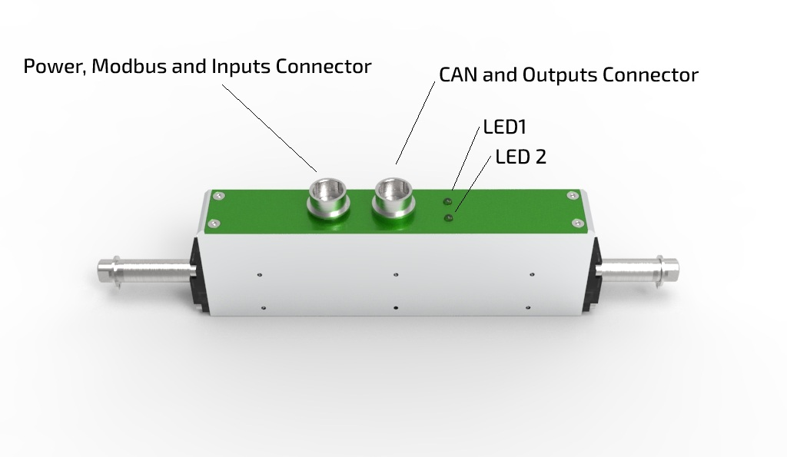
NLi080Q/X is equipped with double connectors Hirose HR10A-10P-12S, the cable DA00002011 from motor and the PLC has the following configuration on the D-SUB 15 male connector.
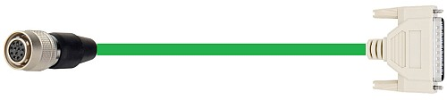cable_da00002011.jpg

CONNECTOR CLOSE TO LED POSITION
PIN | SIGNAL | DESCRIPTION | FUNCTION
1 | NC | NC
2 | CAN_H | CAN HIGH
3 | GND | Ground
4 | +24VDC | Power
5 | +24VDC | Power
6 | GND | Ground
7 | GND | Ground
8 | CAN_H | CAN HIGH
9 | CAN_RES | TERMINATION RESISTANCE
10 | DIG_OUT_0 | Digital output 0 (24V logic,PNP) | Motor running
11 | DIG_OUT_1 | Digital output 1 (24V logic, PNP) | Motor fault
12 | CAN_L | CAN LOW
In order to have the termination on the node, please make a jumper between CAN_RES andf CAN_L (Pin 9 and Pin 11)

CONNECTOR ON THE OPPOSITE SIDE
PIN | SIGNAL | DESCRIPTION | FUNCTION
1 | RS485_B | Modbus B
2 | RS485_A | Modbus A
3 | GND | Ground
4 | +24VDC | Power
5 | +24VDC | Power
6 | GND | Ground
7 | GND | Ground
8 | DIG_IN0 | Digital Input 0 (24V logic) | Enable / Homing
9 | DIG_IN1 | Digital Input 1 (24V logic) | Motion trigger
10 | CAN_H | CAN HIGH
11 | CAN_L | CAN LOW
12 | NC | NC

MODBUS RTU only - SINGLE CONNECTOR
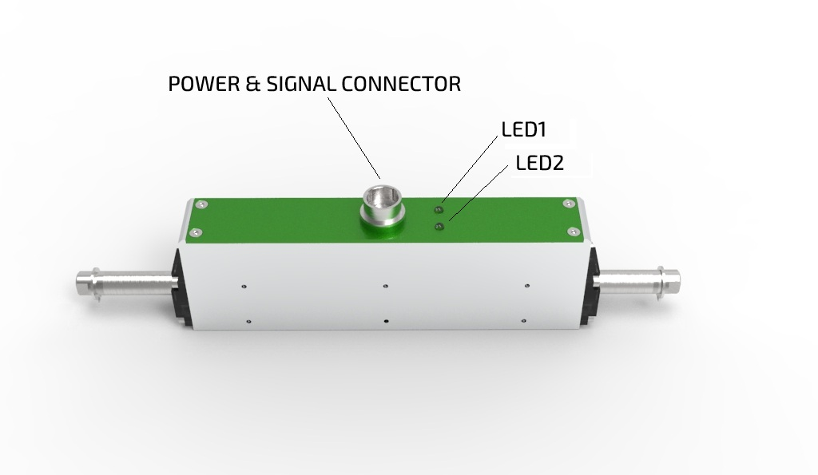nli080q-overview.jpg
NLi080Q/X is equipped with single connector Hirose HR10A-10P-12S, the cable DA00002011 from motor and the PLC has the following configuration on the D-SUB 15 male connector.
cable_da00002011.jpg
D-SUB 15  Pinout | SIGNAL | DESCRIPTION | FUNCTION
1 | RS485_B | Modbus B
2 | RS485_A | Modbus A
3 | GND | Ground
4 | +24VDC | Power
5 | +24VDC | Power
6 | GND | Ground
7 | GND | Ground
8 | DIG_IN_0 | Digital Input 0 (24V logic) | Enable / Homing
9 | DIG_IN_1 | Digital Input 1 (24V logic) | Motion trigger
10 | DIG_OUT_0 | Digital output 0 (24V logic, PNP) | Motor running
11 | DIG_OUT_1 | Digital output 1 (24V logic, PNP) | Motor fault
12 | DIG_OUT_2 | Digital output 2 (24V logic, PNP) | Programmable
The programmable output have the following options: In Position, Homing in progress, Overtemp fault, sin/cos fault, I2T fault, Master sync, gripper command. This is programmable with NiLAB Starter software.

Pinout HIROSE Connector on motor side
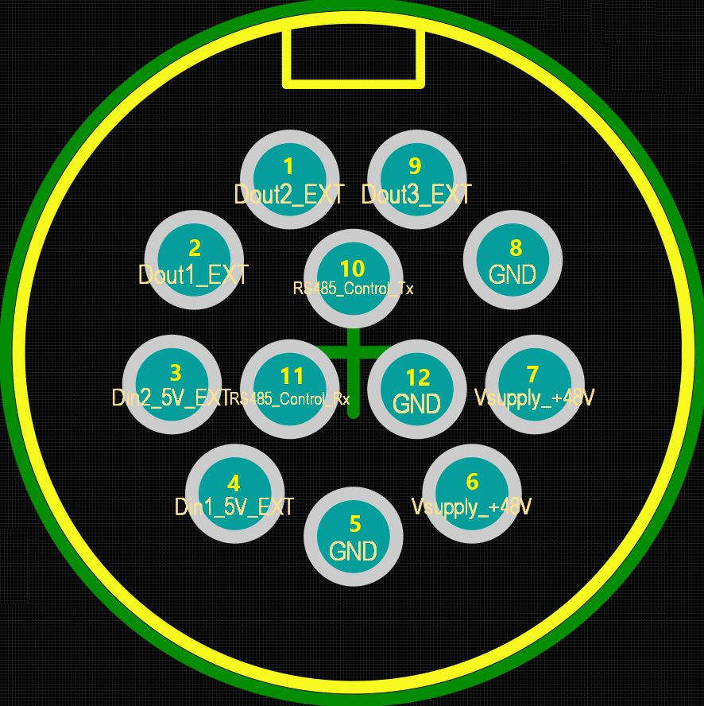conn_corrected_nli080.jpg
PIN | SIGNAL | DESCRIPTION | FUNCTION
9 | DIG_OUT_2 | Digital output 2 (24V logic, PNP) | Programmable
8 | GND | Ground
7 | +24VDC | Power supply
6 | +24VDC | Power supply
5 | GND | Ground
4 | DIG_IN_0 | Digital Input 0 | Enable / Homing
3 | DIG_IN_1 | Digital Input 1 | Motion trigger
2 | DIG_OUT_0 | Digital output 0 (24V logic PNP) | Motor running
1 | DIG_OUT_1 | Digital output 1 (24V logic, PNP) | Motor fault
10 | RS485_TX | Modbus
11 | RS485_RX | Modbus
12 | GND | Ground

