Ports

Lower-side
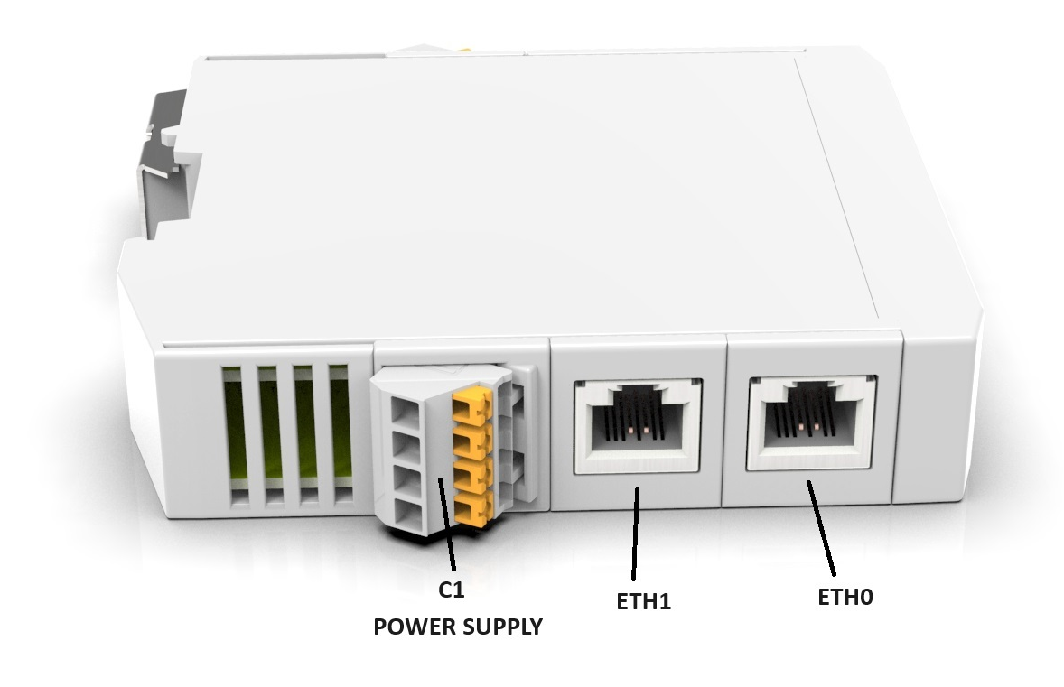

C1 Connector
Pin | Description
1 | 24VDC
2 | GND
3 | 24VDC
4 | GND
ETH0 - PORT IN / ETH1 - PORT OUT

Upper-side
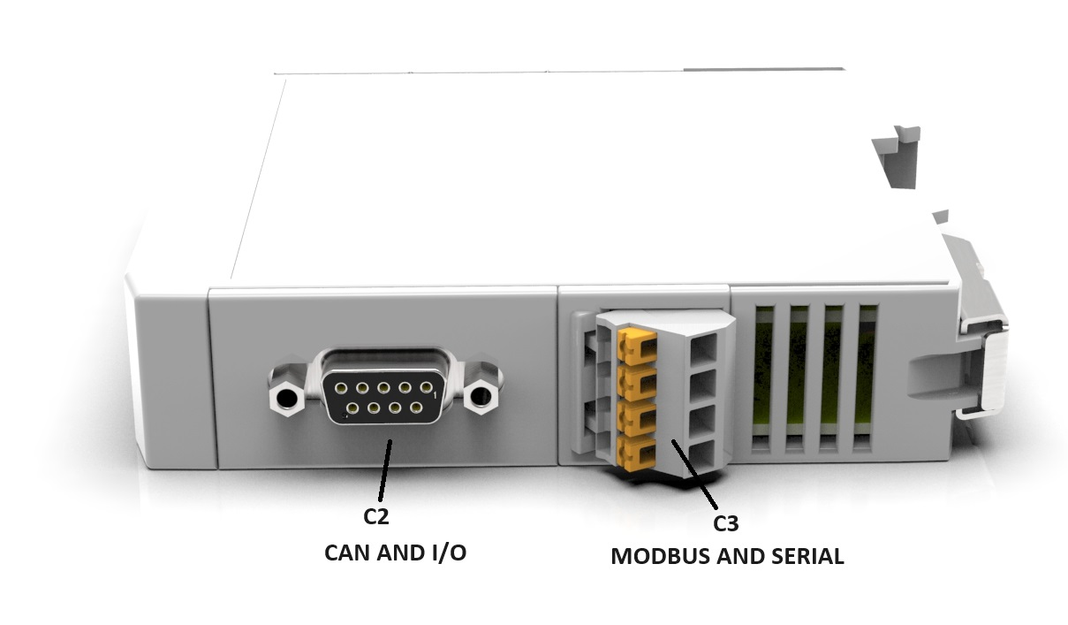

C2 Connector - DSUB9 Male
Pin | Description
1 | DIG_IN1
2 | CAN_L
3 | GND
4 | DIG_OUT1
5 | DIG_OUT2
6 | DIG_IN2
7 | CAN_H
8 | DIG_IN3
9 | DIG_OUT3

C3 MODBUS and Serial COM
Pin | Description
1 | MODBUS B
2 | MODBUS A
3 | –
4 | –
Please, use the USB to UART3V3 cable to connect the gateway with configuration software

