NiLAB Starter
In order to check the status and to read and write a configuration without EtherCAT connection, it is possible to use the NiLAB Starter Commisioning tool.
With this tool you can write the control word, you read the status word, the PDO, PDI mapping and the CANOPEN baud rate.
This software can be downloaded here: https://www.nilab.at/dokuwiki/doku.php?id=nilab_starter:start|
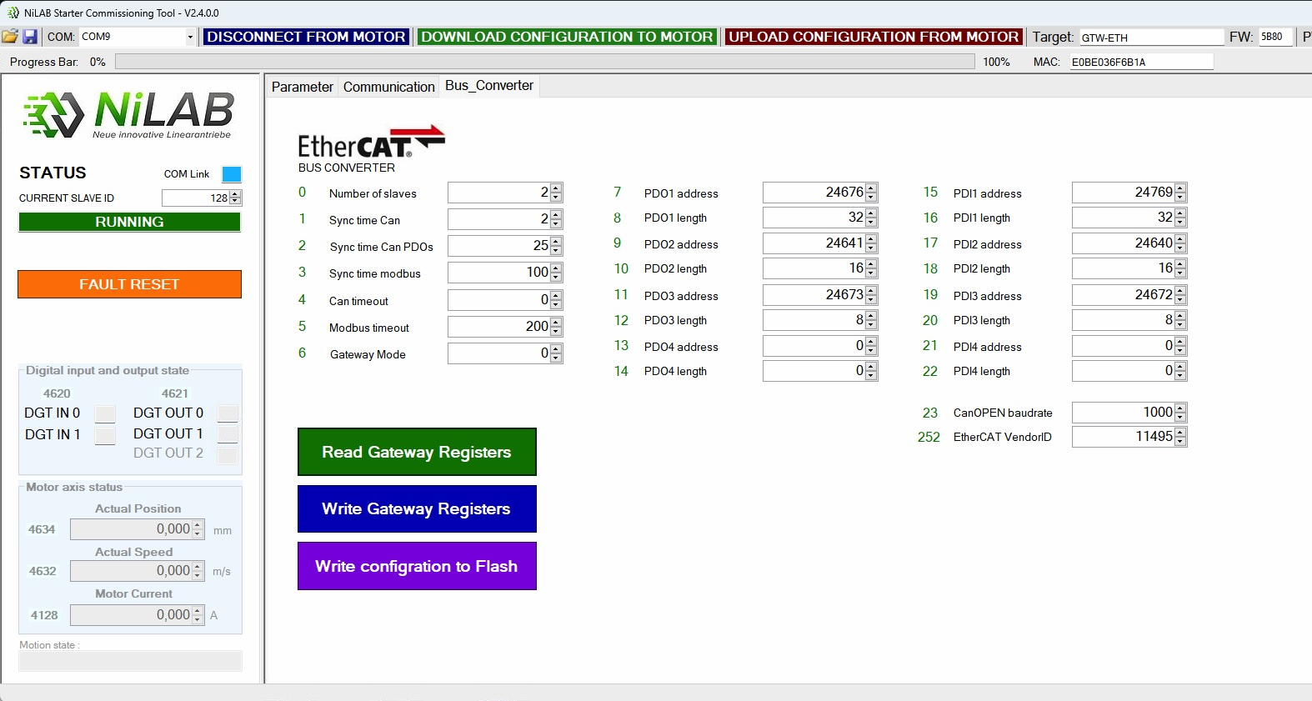nilab_starter.jpg

