Siemens Sinamics S120 / G120

Blocksize
Please considerr that the standard winding of the motor are compatible with 230VAC or 400VAC servo drives.
Select a model of the blocksize (power module of the drive) considering the motor datasheet values: https://www.ni-lab.online/new_websmart/read_datasheet.php
Rated current of the motor must be fullfilled from the rated current of the drive.

G120 (230 VAC power lines)
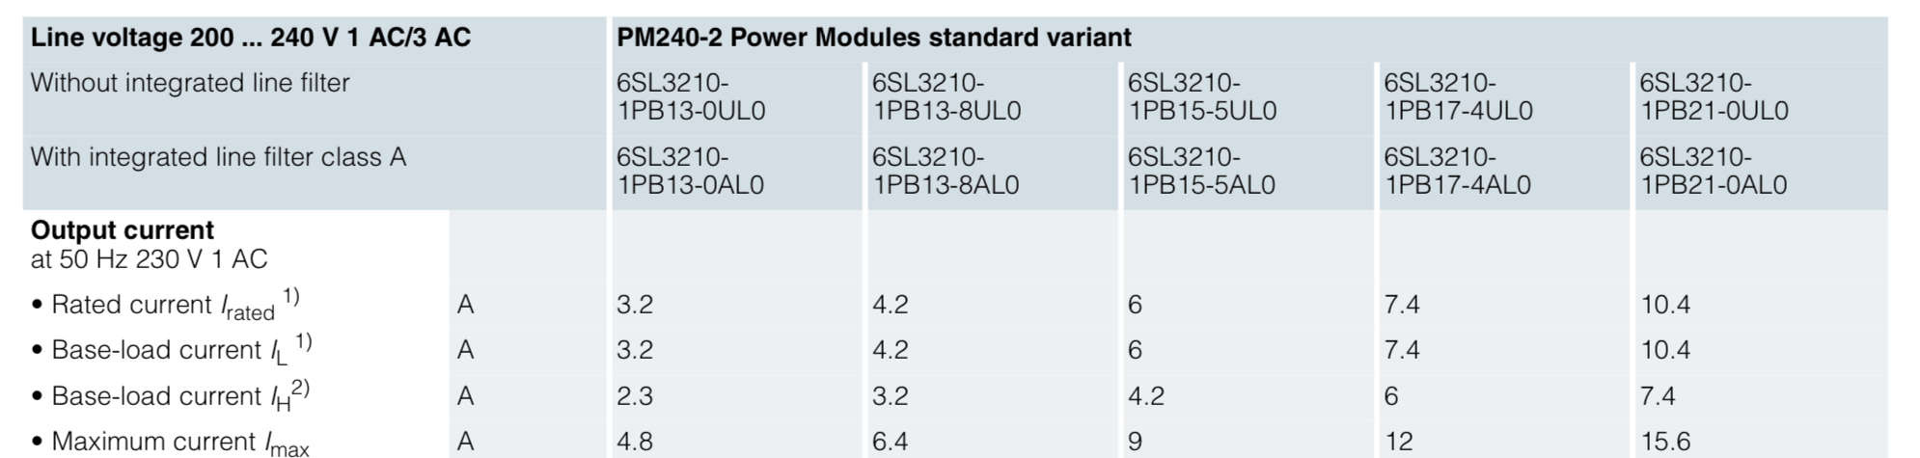img_0123.jpeg

S120 (400 VAC power line)
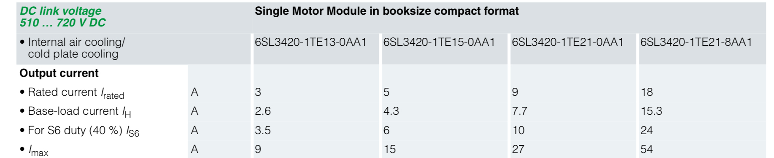img_0124.jpeg

Limitation
warning_symbol.jpg | The pole position identification with S120 and third party motor is possible only using p1980 = 10 ⇒ Motion-based

Motor feedback connection
The motor feedback must be connected using driveCliq converter SMC20 or SME20.
SMC20  6SL3055-0AA00-5BA3 | SME20  6SL3055-0AA00-5EA0
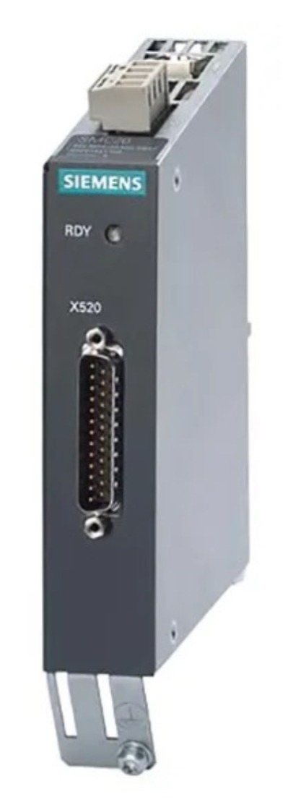img_0121_1.jpeg | 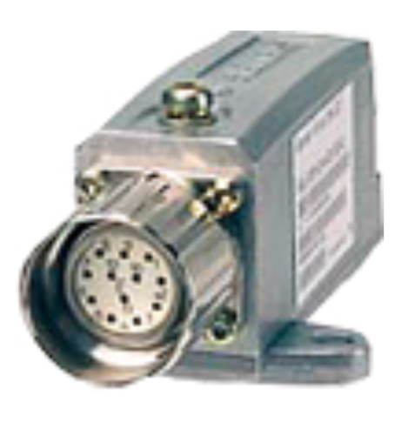img_0122.jpeg
Converter pinout
NiLAB cable wire colors | Signal | SMC20 d-sub25 female | SME20 M23 pinout
Yellow | SIN+ | 3 | 5
Green | SIN- | 4 | 6
Gray | COS+ | 6 | 1
Orange or pink | COS- | 7 | 8
Blue | PTC+ | 25 | 9
Violet | PTC- | 13 | 7
Red | +5VDC | 1+14 | 2+12
Black | GND | 2+16 | 10+11
White-Black | – | – | –
Brown | – | – | –
White | – | – | –
Brown-White | – | – | –
Shield | – | 5+8+24 | –

Parametrization
When creating the drive from scratch, the correct sequence to follow is:
1) Fill the data as in the table below (two example motor are listed in the table)
Parameter | Description | GDI250QS | GD350ES
P305 | Nominal current | 1.2 A | 3.7 A
P311 | Nominal speed | 100 m/min | 100 m/min
P315 | Pole pitch | 60 mm | 60mm
P316 | Force constant | 52 N/A | 72 N/A
P322 | Max speed | 100 m/min | 100 m/min
P323 | Max current | 4.8 A | 16 A
P338 | Current limit | 4.8 A | 16 A
P341 | Slider weight | 1.5 kg | 3 Kg
P350 | phase resistance | 21.5 ohm | 5.03 ohm
P356 | phase inductance | 35 mH | 5.68 mH
P431 | commutation angle | to calculate | to calculate
*) Note that the P341 must be calculate using Pole Position Identification procedure
2) The equivalent circuit data p350 and p356 will then need to be re-entered after the download. This happens because after the system calculations, these values are overwritten. The calculations must be performed to provide consistent values for the current and speed controllers.
3) After the download, enter the datasheet values for resistance and inductance, and also insert a filter on the encoder p1441=1ms or 2ms. Then, deactivate the commutation angle measurement and/or verification by setting p1982=0.
4) For correct operation, the U and V phases must be swapped.
5) If the data already exists, only P431 and P1982=0 need to be modified, remembering that p431 can only be modified by setting p10=4 and then setting it back to p10=0.

Pole position identification
The drive must be enabled using the inductance-based pole position identification (p1980 = 10 ⇒ Motion-based).
Please set the parameter p0325 ⇒ Motor pole position identification current 1st phase ⇒ Rated Current of the motor and parameter p0329 ⇒ Motor pole position identification current ⇒ Rated current of the motor. See attached Siemens manual section for reference: :green_drive_motors:pole_position_identification.pdf

Detailed procedure
1. Enable the measure of the commutation angle setting P10=4, P1982=1, P1990=1, P1980=10, P1993=50% of the rated current of the motor. P1994=2 sec, p1997=max value.
2. After the movement p431 is shown.
3. Change the parameter p10=0, P1982=0 and P1980=0 that means pole position detection measure disabled.

