Lexium32M Drive
In order to commissioning the LXM32M Schneider Electric servo drive, you need to install and use SoMove Software from Schneider Electric. The Lexium32M drive must be equipped with Analog Encoder module VW3M3403. A third-party motor must be configure using SoMove software. A TPMConfig file with the motor data will be imported following the steps below.
Example of TPMConfig file:
GD250XS ⇒ :green_drive_motors:gd250xs.tpmconfig.zip
GDI250QS ⇒ :green_drive_motors:gdi250qs.tpmconfig.zip
GD350ES ⇒ :green_drive_motors:gd350es.tpmconfig.zip
GD350XS ⇒ :green_drive_motors:gd350xs.zip
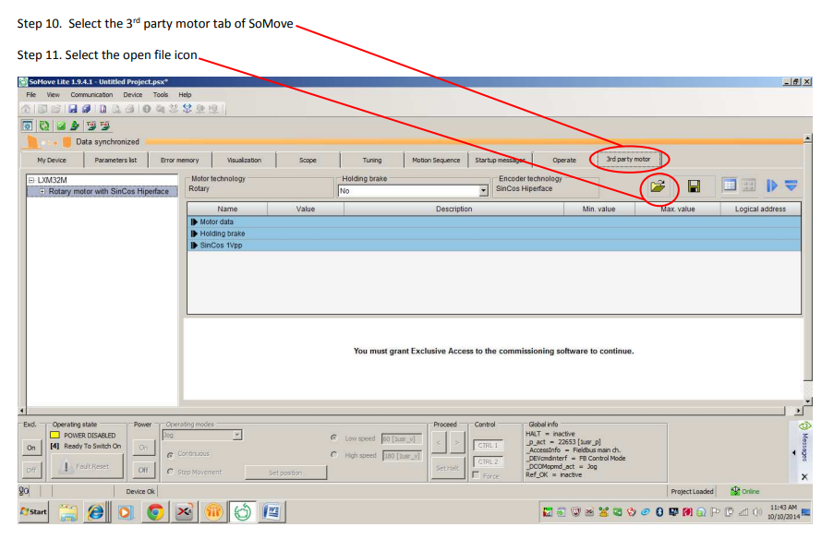
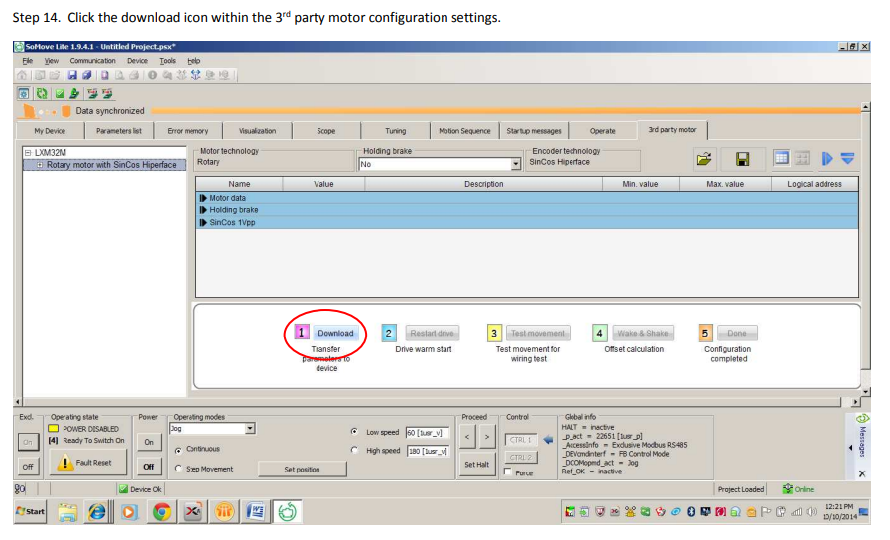
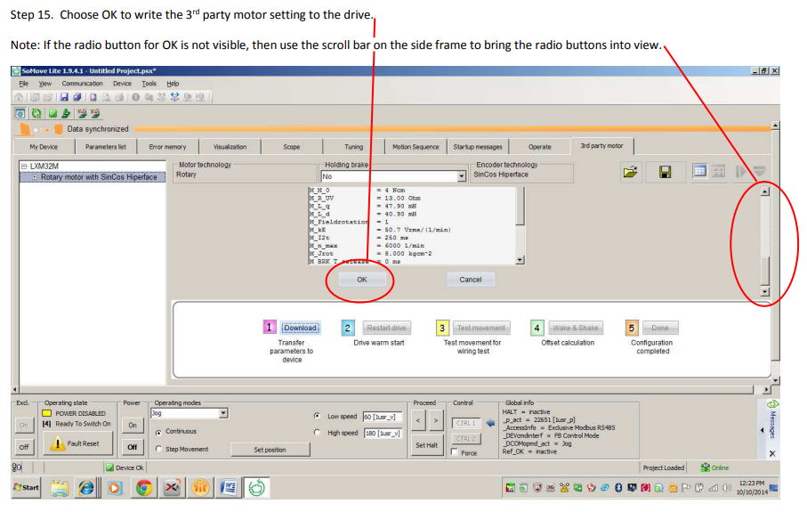
After these steps follow the wizard 1→2→3→4→5 buttons.
Please, check during the Test Movement that with positive speed you have positive encoder counts.
After the last step of the wizard, please use Autotune function to calculate the right control loops parameters.
Please, cosider that the Autotune tends to use large gain and this can be result in vibrations.
So, after autotuning please reduce of 20% the speed gain (Kpn).

Example of starting control loops parameters


