Dimensional details

GD16 dimensions
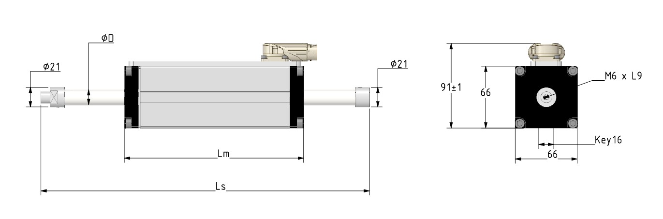gd16_drawing.jpg
MOTOR | STATOR LENGHT Lm | SLIDER LENGTH Ls | UNIT
GD160D | 159 | Stroke + 159 + terminals | mm
GD160T | 189 | Stroke + 189 + terminals | mm
GD160Q | 219 | Stroke + 219 + terminals | mm

GD250 Dimensions
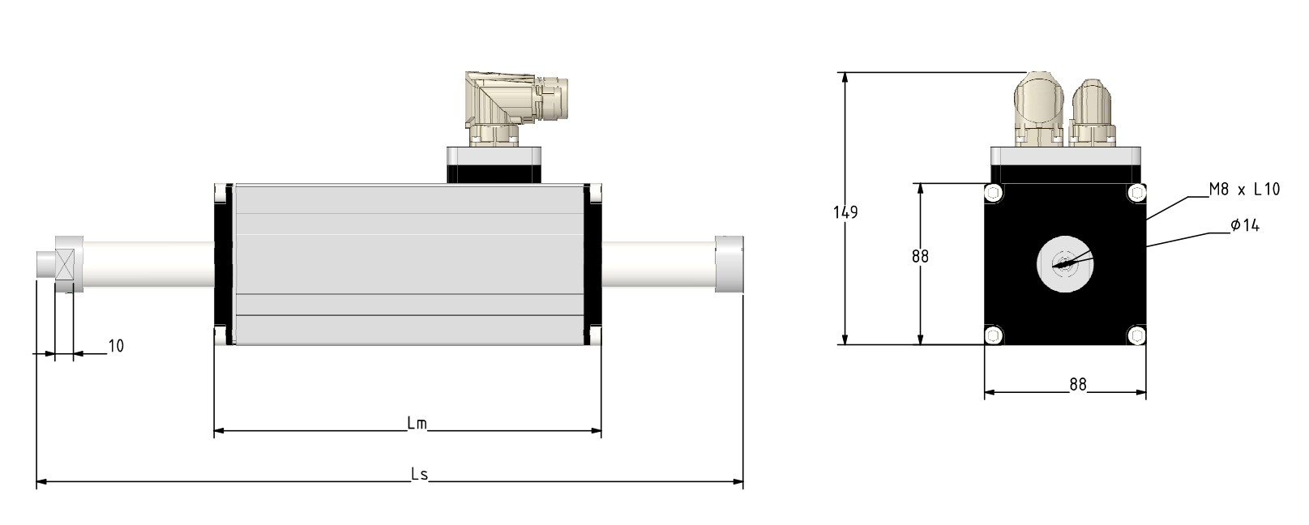gd25_drawing.jpg
MOTOR | STATOR LENGHT Lm | SLIDER LENGTH Ls | UNIT
GD250D | 160 | Stroke + 160 + terminals | mm
GD250T | 190 | Stroke + 190 + terminals | mm
GD250Q | 210 | Stroke + 210 + terminals | mm
GD250X | 340 | Stroke + 340 + terminals | mm

GD350 Dimensions
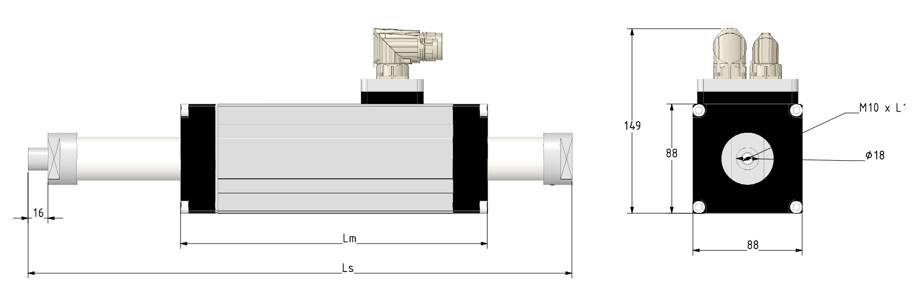
MOTOR | STATOR LENGHT Lm | SLIDER LENGTH Ls | UNIT
GD350TS | 226 | Stroke + 226 + terminals | mm
GD350XS | 376 | Stroke + 376 + terminals | mm
GD350ES | 502 | Stroke + 502 + terminals | mm

