Connection system

Stator side with Y-TEC
PIN | FUNCTION | CONNECTOR VIEW FRONT | PIN | FUNCTION
12 | SIN+/SLO+ | 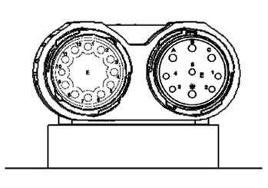connector_ytec.jpg | A | W
11 | SIN-/SLO- |  | B | U
10 | COS+/MA- |  | C | V
9 | COS-/MA+ |  | Earth | PE
8 | PTC-/A- |  | 1 | -
7 | PTC+/A+ |  | 2 | -
6 | +5VDC |  | 3 | -
5 | GND |  | 4 | -
4 | - |  | 5 | -
3 | -/B-
2 | -/B+
1 | -
Connector type: EEDA101NN00000002000

Stator side with Speedtec M23 and M17
PIN | FUNCTION | CONNECTOR VIEW FRONT | PIN | FUNCTION
12 | SIN+/SLO+ | 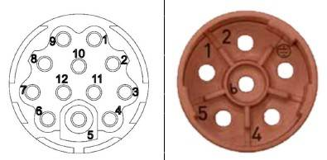m23_m17_connector.jpg | 1 | U
11 | SIN-/SLO- |  | 2 | V
10 | COS+/MA- |  | Earth | PE
9 | COS-/MA+ |  | 4 | -
8 | PTC-/A- |  | 5 | -
7 | PTC+/A+ |  | 6 | W
6 | +5VDC
5 | GND
4 | -
3 | -/B-
2 | -/B+
1 | -
Connectors: Intercontec Speedtec AEDC047NN0000051A000 (M17) + BEDC106NN00000201000 (M23)

